COURSE CONTENTS
CMP 101: INTRODUCTION TO COMPUTER SCIENCE: (3 Units) (L 30: P: 45)
History of Computer Science and their generations. Computer Hardware; functional components Modern I/O units Software: Operating Systems, Application Packages, Program Development; Flow charts and algorithms; Program Objects, Introduction to FORTRAN, BASIC or VISUAL BASIC Fundamentals.

OBJECTIVES
The specific objectives of this course are to:
- Understand the history, classification and impact of computers.
- Know the concept of computer hardware and software.
- Understand features of a good program.
- Understand the concept of Algorithms and flowcharting.
- Understand the principles of designing algorithms for common programming problem.
- Understand the concept of debugging and maintaining program.

LEARNING OUTCOMES
The students should be able to:
- Define computer
- Know the history, classification and computer applications
- Know the concept of computer hardware
- Know the concept of computer software.
- Know the data preparation methods
- Know the Characteristics of a Computer.
- Know features of a good program.
- Explain the concept of Computer problem solving techniques, Algorithms and flowcharting.
- Explain General modular program design principles.
- Explain expressions and control structure.
- Explain the procedure in solving programming problems.
- Explain the concept of debugging and maintaining program.
- Know programming style in FORTRAN
- Know how to debug programs in FORTRAN.

TEXT BOOK(S):
- Goel, A. (2010). Computer fundamentals. Pearson Education India.
- Chivers, I. D., & Sleightholme, J. (2018). Introduction to programming with Fortran (Vol. 2). Cham: Springer.
Course Writer/Developer: Dr. F.E. AYO, Department of Mathematical Sciences, Computer science unit, Olabisi Onabanjo University, Ago-Iwoye.
E-mail: ayo.femi@oouagoiwoye.edu.ng
LESSON 1
DEFINITION OF COMPUTER
A computer is an electronic device that accepts data from the user, processes it, produces results, displays them to the users, and stores the results for future usage.
In other words, a computer is basically defined as a tool or machine used for processing data to give required information. It is capable of:
- taking input data through the keyboard (input unit)
- storing the input data in a diskette, hard disk or other medium
- processing it at the central processing unit (CPU) and
- giving out the result (output) on the screen or the Visual Display Unit (VDU).
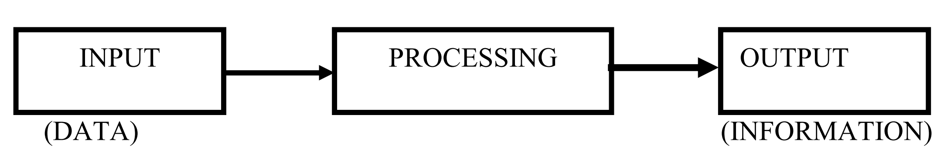
Figure 1: Schematic diagram to define a computer
Data is a collection of unorganized facts & figures and does not provide any further information regarding patterns, context, etc. Hence data means "unstructured facts and figures".
Information is a structured data i.e. organized meaningful and processed data. To process the data and convert into information, a computer is used.
Methods of Data Processing
The following are the three major methods that have been widely used for data processing over the years:
a. Manual method
b. Mechanical method and
c. Computer method.
Manual Method
The manual method of data processing involves the use of chalk, wall, pen, pencil etc. These devices or tools facilitate human efforts in recording, classifying, manipulating, sorting and presenting data or information. The manual data processing operations entail considerable manual efforts. Thus, manual method is cumbersome, tiresome, boring, frustrating and time consuming. Furthermore, the processing of data by the manual method is likely to be affected by human errors. The manual method does not allow for the processing of large volume of data on a regular and timely basis.
Mechanical Method
The mechanical method of data processing involves the use of machines such as typewriter, adding machines and the like. These machines facilitate human efforts in recording, classifying, manipulating, sorting and presenting data or information. The mechanical operations are noisy, hazardous, error prone and untidy. The mechanical method does not allow for the processing of large volume of data continuously and timely.
Computer Method
The computer method of carrying out data processing has the following major features:
a. Data can be steadily and continuously processed.
b. The operations are practically not noisy.
c. There is a store where data and instructions can be stored temporarily and permanently.
d. Errors can be easily and neatly corrected.
e. Output reports are usually very neat, decent and can be produced in various forms such as adding graphs, diagrams, pictures etc.
f. Accuracy and reliability are highly enhanced.

CHARACTERISTICS OF A COMPUTER
The characteristics of the computer system are as follows –

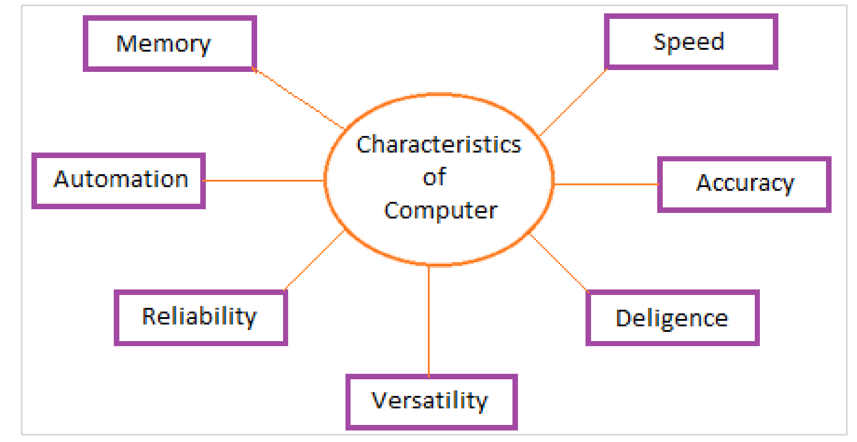
Figure 2: Characteristics of computer
Speed
- Computer is a very fast device.
- It is capable of performing calculation of very large amount of data.
- The computer has units of speed in microsecond, nanosecond, and even the picosecond.
- It can perform millions of calculations in a few seconds as compared to man who will spend many months to perform the same task.
Accuracy
- In addition to being very fast, computers are very accurate.
- The calculations are 100% error free.
- Computers perform all jobs with 100% accuracy provided that the input is correct.
Storage Capability
- Memory is a very important characteristic of computers.
- A computer has much more storage capacity than human beings.
- It can store large amount of data.
- It can store any type of data such as images, videos, text, audio, etc.
Reliability
- A computer is a reliable machine.
- Modern electronic components have long lives.
- Computers are designed to make maintenance easy.
Automation
- Computer is an automatic machine.
- Automation is the ability to perform a given task automatically. Once the computer receives a program i.e., the program is stored in the computer memory, then the program and instruction can control the program execution without human interaction.
Reduction in paper work and cost
- The use of computers for data processing in an organization leads to reduction in paper work and results in speeding up the process.
- As data in electronic files can be retrieved as and when required, the problem of maintenance of large number of paper files gets reduced.
- Though the initial investment for installing a computer is high, it substantially reduces the cost of each of its transaction.
Diligence
- Unlike human beings, a computer is free from monotony, tiredness, and lack of concentration.
- It can work continuously without any error and boredom.
- It can perform repeated tasks with the same speed and accuracy.
Versatility
- A computer is a very versatile machine.
- A computer is very flexible in performing the jobs to be done.
- This machine can be used to solve the problems related to various fields.
- At one instance, it may be solving a complex scientific problem and the very next moment it may be playing a card game.

HISTORY OF COMPUTER
The history of computer can be classified into generations.
Initially, the generation term was used to distinguish between varying hardware technologies. Nowadays, generation includes both hardware and software, which together make up an entire computer system.
There are five computer generations known till date. Each generation has been discussed in detail along with their time period and characteristics. Following are the main five generations of computers.
First Generation Computers
The period of first generation was from 1946-1959. The computers of first generation used vacuum tubes as the basic components for memory and circuitry for CPU (Central Processing Unit). These tubes, like electric bulbs, produced a lot of heat and the installations used to fuse frequently. Therefore, they were very expensive and only large organizations were able to afford it.
In this generation, mainly batch processing operating system was used. Punch cards, paper tape, and magnetic tape was used as input and output devices. The computers in this generation used machine code as the programming language.
The main features of the first generation are:
- Vacuum tube technology
- Unreliable
- Supported machine language only
- Very costly
- Generated a lot of heat
- Slow input and output devices
- Huge size
- Need of AC
- Non-portable
- Consumed a lot of electricity
- Example is mainframe computer
Second Generation Computers
The period of second generation was from 1959-1965. In this generation, transistors were used that were cheaper, consumed less power, more compact in size, more reliable and faster than the first-generation machines made of vacuum tubes. In this generation, magnetic cores were used as the primary memory and magnetic tape and magnetic disks as secondary storage devices.
In this generation, assembly language and high-level programming languages like FORTRAN, COBOL were used. The computers used batch processing and multiprogramming operating system.
The main features of second generation are:
- Use of transistors
- Reliable in comparison to first generation computers
- Smaller size as compared to first generation computers
- Generated less heat as compared to first generation computers
- Consumed less electricity as compared to first generation computers
- Faster than first generation computers
- Still very costly
- AC required
- Supported machine and assembly languages
- Examples are IBM 1620 and IBM 7094

Third Generation Computers
The period of third generation was from 1965-1971. The computers of third generation used Integrated Circuits (ICs) in place of transistors. A single IC has many transistors, resistors, and capacitors along with the associated circuitry.
The IC was invented by Jack Kilby. This development made computers smaller in size, reliable, and efficient. In this generation remote processing, time-sharing, multiprogramming operating system were used. High-level languages (FORTRAN-II TO IV, COBOL, PASCAL PL/1, BASIC, ALGOL-68 etc.) were used during this generation.
The main features of third generation are:
- IC used
- More reliable in comparison to previous two generations
- Smaller size
- Generated less heat
- Faster
- Lesser maintenance
- Costly
- AC required
- Consumed lesser electricity
- Supported high-level language
- Examples are IBM-360 series, Honeywell-6000 series and PDP (Personal Data Processor).

Fourth Generation Computers
The period of fourth generation was from 1971-1980. Computers of fourth generation used Very Large Scale Integrated (VLSI) circuits. VLSI circuits having about 5000 transistors and other circuit elements with their associated circuits on a single chip made it possible to have microcomputers of fourth generation.
Fourth generation computers became more powerful, compact, reliable, and affordable. As a result, it gave rise to Personal Computer (PC) revolution. In this generation, time sharing, real time networks, distributed operating system were used. All the high-level languages like C, C++, Java, etc., were used in this generation.

The main features of fourth generation are:
- VLSI technology used
- Very cheap
- Portable and reliable
- Use of PCs
- Very small size
- Pipeline processing
- No AC required
- Concept of internet was introduced
- Great developments in the fields of networks
- Computers became easily available
- Example include Super Computers

Fifth Generation Computers
The period of fifth generation is 1980-till date. In the fifth generation, VLSI technology became ULSI (Ultra Large-Scale Integration) technology, resulting in the production of microprocessor chips having ten million electronic components.
This generation is based on parallel processing hardware and AI (Artificial Intelligence) software. AI is an emerging branch in computer science, which interprets the means and method of making computers think like human beings. All the high-level languages like C and C++, Java, python, .Net etc., are used in this generation.
AI includes:
- Robotics
- Neural Networks
- Game Playing
- Development of expert systems to make decisions in real-life situations
- Natural language understanding and generation
The main features of fifth generation are:
- ULSI technology
- Development of true artificial intelligence
- Development of Natural language processing
- Advancement in Parallel Processing
- Advancement in Superconductor technology
- More user-friendly interfaces with multimedia features
- Availability of very powerful and compact computers at cheaper rates
- Some computer types of this generation are: Desktop, Laptop, NoteBook, UltraBook and ChromeBook.

BASIC APPLICATIONS OF COMPUTER
Computers play a role in every field of life. They are used in homes, business, educational institutions, research organizations, medical field, government offices, entertainment, etc.
Home
Computers are used at homes for several purposes like online bill payment, watching movies or shows at home, home tutoring, social media access, playing games, internet access, etc. They provide communication through electronic mail. They help to avail work from home facility for corporate employees. Computers help the student community to avail online educational support.
Medical Field
Computers are used in hospitals to maintain a database of patients’ history, diagnosis, Xrays, live monitoring of patients, etc. Surgeons nowadays use robotic surgical devices to perform delicate operations, and conduct surgeries remotely. Virtual reality technologies are also used for training purposes. It also helps to monitor the foetus inside the mother’s womb.
Entertainment
Computers help to watch movies online, play games online; act as a virtual entertainer in playing games, listening to music, etc. MIDI instruments greatly help people in the entertainment industry in recording music with artificial instruments. Videos can be fed from computers to full screen televisions. Photo editors are available with fabulous features.
Industry
Computers are used to perform several tasks in industries like managing inventory, designing purpose, creating virtual sample products, interior designing, video conferencing, etc. Online marketing has seen a great revolution in its ability to sell various products to inaccessible corners like interior or rural areas. Stock markets have seen phenomenal participation from different levels of people through the use of computers.
Education
Computers are used in education sector through online classes, online examinations, referring e-books, online tutoring, etc. They help in increased use of audio-visual aids in the education field.
Government
In government sectors, computers are used in data processing, maintaining a database of citizens and supporting a paperless environment. The country’s defence organizations have greatly benefitted from computers in their use for missile development, satellites, rocket launches, etc.
Banking
In the banking sector, computers are used to store details of customers and conduct transactions, such as withdrawal and deposit of money through ATMs. Banks have reduced manual errors and expenses to a great extent through extensive use of computers.

Business
Nowadays, computers are totally integrated into business. The main objective of business is transaction processing, which involves transactions with suppliers, employees or customers. Computers can make these transactions easy and accurate. People can analyze investments, sales, expenses, markets and other aspects of business using computers.
Training
Many organizations use computer-based training to train their employees, to save money and improve performance. Video conferencing through computers allows saving of time and travelling costs by being able to connect people in various locations.
Arts
Computers are extensively used in dance, photography, arts and culture. The fluid movement of dance can be shown live via animation. Photos can be digitized using computers.
Science and Engineering
Computers with high performance are used to stimulate dynamic process in Science and Engineering. Supercomputers have numerous applications in area of Research and Development (R&D). Topographic images can be created through computers. Scientists use computers to plot and analyze data to have a better understanding of earthquakes.

LESSON 2
COMPONENTS OF COMPUTER SYSTEM
Computer systems consist of three components as shown in below image: Central Processing Unit, Input devices and Output devices. Input devices provide data input to processor, which processes data and generates useful information that’s displayed to the user through output devices. This is stored in computer’s memory.
Central Processing Unit
The Central Processing Unit (CPU) is called “the brain of computer” as it controls operation of all parts of computer. It consists of two components: Arithmetic Logic Unit (ALU), and Control Unit.
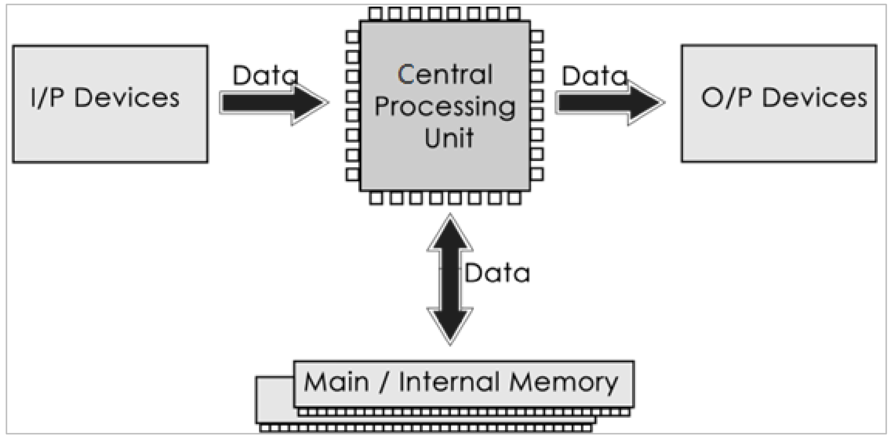
Figure 3: Components of Computer System
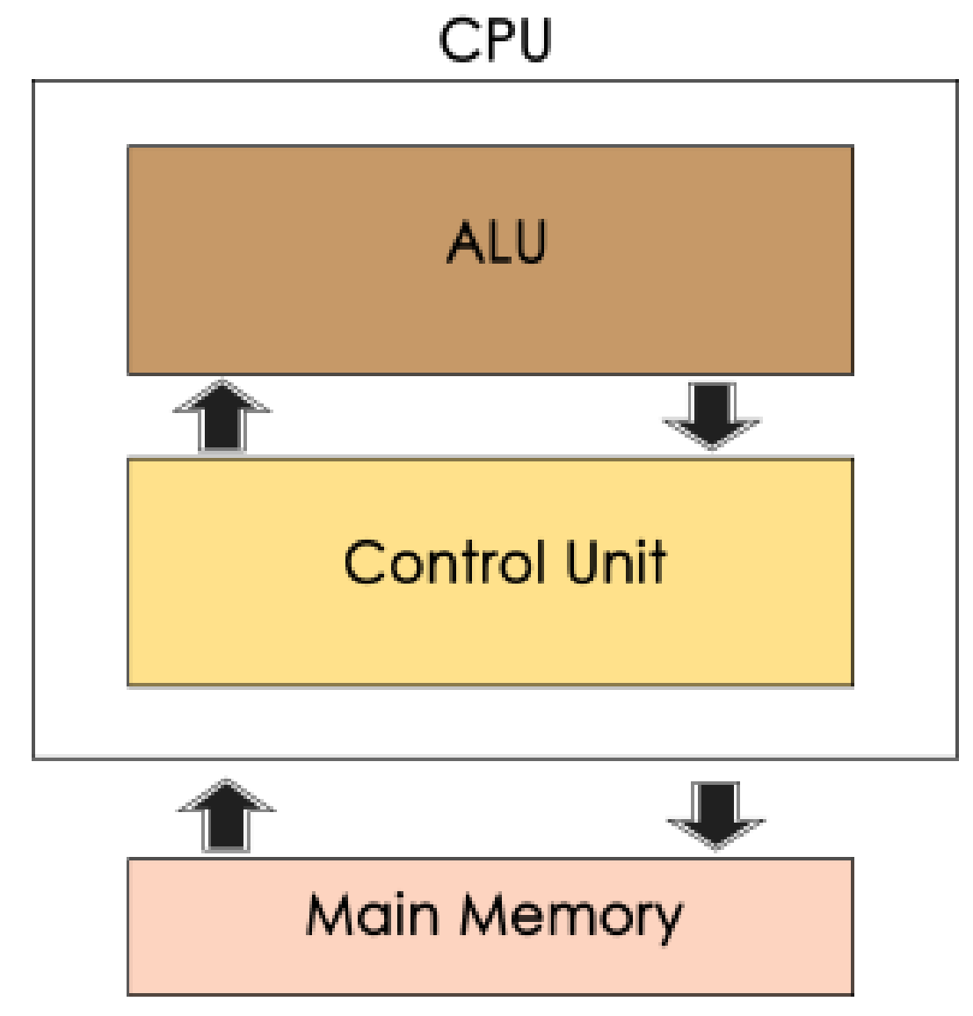
Figure 4: Central Processing Unit

Arithmetic Logic Unit (ALU)
Data entered into computer is sent to RAM, from where it is then sent to ALU, where rest of data processing takes place. All types of processing, such as comparisons, decision-making and processing of non-numeric information takes place here and once again data is moved to RAM.
Control Unit
As name indicates, this part of CPU extracts instructions, performs execution, maintains and directs operations of entire system.
Functions of Control Unit
Control unit performs following functions:
- It controls all activities of computer
- Supervises flow of data within CPU
- Directs flow of data within CPU
- Transfers data to Arithmetic and Logic Unit
- Transfers results to memory
- Fetches results from memory to output devices
Memory Unit
This is unit in which data and instructions given to computer as well as results given by computer are stored. Unit of memory is “Byte”. One byte is 8 bits.
Input Devices–Keyboard and Mouse
Input devices help to get input or data from user. Some of input devices are:
Input device | Characteristic
Keyboard | - The keyboard was the first peripheral device to be used with computers.  - It helps to input text and numbers into computer.  - It consists of 104 keys and 12 functional keys.
Mouse | - A mouse is an input device which is also called as pointing device because it helps to point data on screen.  - It also helps to select, highlight content and drag-drop controls.
Trackballs | - A trackball is also a pointing device which will work like a mouse. It is mainly used for gaming and entertainment purpose.
Digital Pens | - A digital pen is another input device which is mostly used with tablets, PDAs, etc.  - A digital pen is also called as a Stylus which helps to write or draw data over pad.
Scanners | - Scanners transform printed material and photographs into a digital representation.  - After scanning of printed material, page is represented in memory as an array of pixels.
Barcode readers | - Barcode reader helps to read information which is printed as bars in back of goods or items.  - Barcode readers are most widely used input devices which we can see in most of products in our day to day life.
Voice Recognition  System | - Voice recognition system interprets or receives dictation or spoken commands to authorize user.
Touch screen | - A touch screen is an input device which uses sensors to sense touch of users to get input data.

KEYBOARD
Keyboard is the most common and very popular input device which helps to input data to the computer. The layout of the keyboard is like that of traditional typewriter, although there are some additional keys provided for performing additional functions.
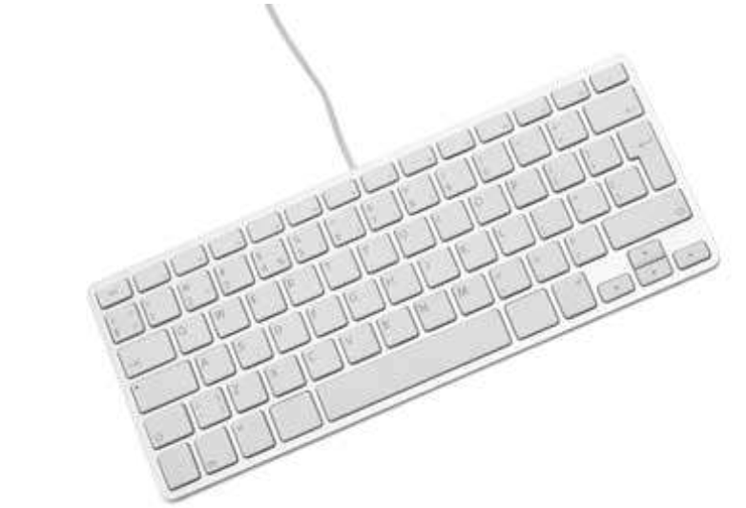
Keyboards are of two sizes 84 keys or 101/102 keys, but now keyboards with 104 keys or 108 keys are also available for Windows and Internet.
The keys on the keyboard are as follows:
S/N | Keys | Description
1 | Typing Keys | These keys include the letter keys (A-Z) and digit keys (0-  9) which generally give the same layout as that of  typewriters.
2 | Numeric Keypad | It is used to enter the numeric data or cursor movement.  Generally, it consists of a set of 17 keys that are laid out  in the same configuration used by most adding machines  and calculators.
3 | Function Keys | The twelve function keys are present on the keyboard  which are arranged in a row at the top of the keyboard.  Each function key has a unique meaning and is used for  some specific purpose.
4 | Control keys | These keys provide cursor and screen control. It includes  four directional arrow keys. Control keys also include  Home, End, Insert, Delete, Page Up, Page Down,  Control(Ctrl), Alternate(Alt), Escape(Esc).
5 | Special Purpose  Keys | Keyboard also contains some special purpose keys such as  Enter, Shift, Caps Lock, Num Lock, Space bar, Tab, and  Print Screen.

Output Devices
Output device | Characteristic
Monitor | - A monitor is most common type of output device.  - It is also called as “Visual Display Unit”.  - The inputs given by keyboard or any other input devices will get displayed on monitor.  - Cathode Ray Tube (CRT) and Flat panel display monitors are commonly used monitors.
Printers | - Printers are most common type of output devices which are used to take a hard copy of any digital document.  - The two types of printers are impact and non-impact printers.  - Non-impact printers such as laser and inkjet printers are less noisy, more reliable and faster and also offer high quality compared to impact printers.
Sound Systems | - Sound systems are output devices which are used to get multimedia content such as voice, music, etc., as output. Some of examples of sound systems are speakers, headphones, and microphones.

PRINTERS
Printer is an output device, which is used to print information on paper.
There are two types of printers:
- Impact Printers
- Non-Impact Printers

IMPACT PRINTERS
Impact printers print the characters by striking them on the ribbon, which is then pressed on the paper.
Characteristics of Impact Printers are the following:
- Very low consumable costs
- Very noisy
- Useful for bulk printing due to low cost
- There is physical contact with the paper to produce an image
These printers are of two types -
- Character printers
- Line printers

Character Printers
Character printers are the printers which print one character at a time.
These are further divided into two types:
- Dot Matrix Printer (DMP)
- Daisy Wheel

Dot Matrix Printer
In the market, one of the most popular printers is Dot Matrix Printer. These printers are popular because of their ease of printing and economical price. Each character printed is in the form of pattern of dots and head consists of a Matrix of Pins of size (5*7, 7*9, 9*7 or 9*9) which come out to form a character which is why it is called Dot Matrix Printer.
Advantages
- Inexpensive
- Widely Used
- Other language characters can be printed
Disadvantages
- Slow Speed
- Poor Quality
Daisy Wheel
Head is lying on a wheel and pins corresponding to characters are like petals of Daisy (flower) which is why it is called Daisy Wheel Printer. These printers are generally used for word-processing in offices that require a few letters to be sent here and there with very nice quality.
Advantages
- More reliable than DMP
- Better quality
- Fonts of character can be easily changed
Disadvantages
- Slower than DMP
- Noisy
- More expensive than DMP

Line Printers
Line printers are the printers which print one line at a time.
These are of two types -
- Drum Printer
- Chain Printer

Drum Printer
This printer is like a drum in shape hence it is called drum printer. The surface of the drum is divided into a number of tracks. Total tracks are equal to the size of the paper, i.e., for a paper width of 132 characters, drum will have 132 tracks. A character set is embossed on the track. Different character sets available in the market are 48-character set, 64 and 96 characters set. One rotation of drum prints one line. Drum printers are fast in speed and can print 300 to 2000 lines per minute.
Advantages
- Very high speed
Disadvantages
- Very expensive
- Characters fonts cannot be changed

Chain Printer
In this printer, a chain of character sets is used, hence it is called Chain Printer. A standard character set may have 48, 64, or 96 characters.

Advantages
- Character fonts can easily be changed.
- Different languages can be used with the same printer.
Disadvantages
- Noisy

NON-IMPACT PRINTERS
Non-impact printers print the characters without using the ribbon. These printers print a complete page at a time; thus they are also called as Page Printers.
These printers are of two types -
- Laser Printers
- Inkjet Printers
Characteristics of Non-impact Printers
- Faster than impact printers
- They are not noisy
- High quality
- Supports many fonts and different character size

Laser Printers
These are non-impact page printers. They use laser lights to produce the dots needed to form the characters to be printed on a page.
Advantages
- Very high speed
- Very high-quality output
- Good graphics quality
- Supports many fonts and different character size
Disadvantages
- Expensive
- Cannot be used to produce multiple copies of a document in a single printing

Inkjet Printers
Inkjet printers are non-impact character printers based on a relatively new technology. They print characters by spraying small drops of ink onto paper. Inkjet printers produce high quality output with presentable features.
They make less noise because no hammering is done and these have many styles of printing modes available. Colour printing is also possible. Some models of Inkjet printers can produce multiple copies of printing also.
Advantages
- High quality printing
- More reliable
Disadvantages
- Expensive as the cost per page is high
- Slow as compared to laser printer

COMPUTER MEMORY
Computer memory refers to storage area where data is stored. It is of two types:
- Primary Memory
- Secondary Memory
Primary Memory
Primary memory is the main memory of computer present in motherboard. Primary memory is of two types as shown in the image below.
Random Access Memory
RAM is referred as temporary memory, in which, information stored is lost once computer is turned off. It is a volatile memory. Instructions written in this memory can be modified; hence it is also known as programmable memory. The two types of RAM are Static RAM (faster and costlier) and Dynamic RAM.
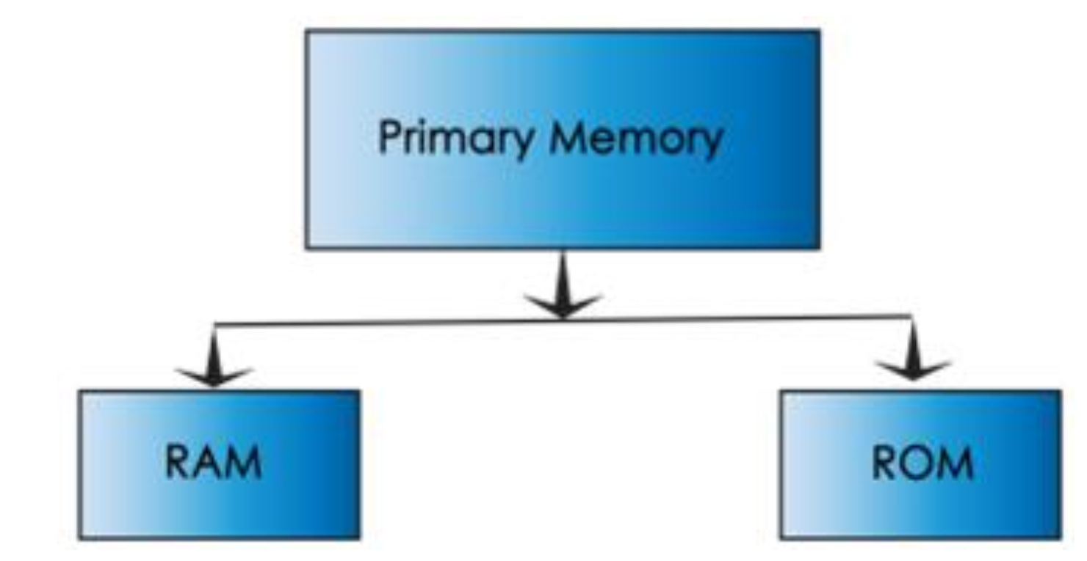
Figure 5: Schematic diagram of primary memory
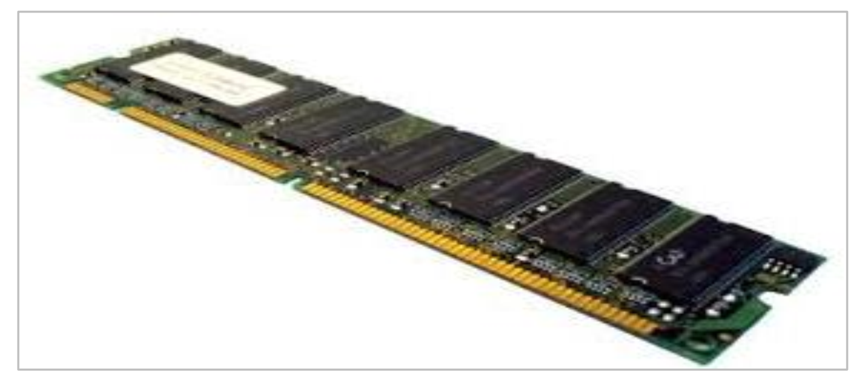
Figure 6: Diagram of RAM

Functions of RAM
- It stores data till it gets processed.
- It stores instructions for data processing.
- It acts as a working space where data processing takes place and intermediate results are stored.
- It stores processed data/results before it is sent to output devices.

Read Only Memory
ROM is referred as permanent memory, in which information stored is available even if computer is turned off. Instructions stored in this memory can only be read and cannot be modified. Mostly ROM has a start-up instruction which is executed every time when computer is switched on. Types of ROM are PROM (Programmable Read Only Memory), EPROM (Erasable PROM), EEPROM (Electrically Erasable PROM) and flash memory.
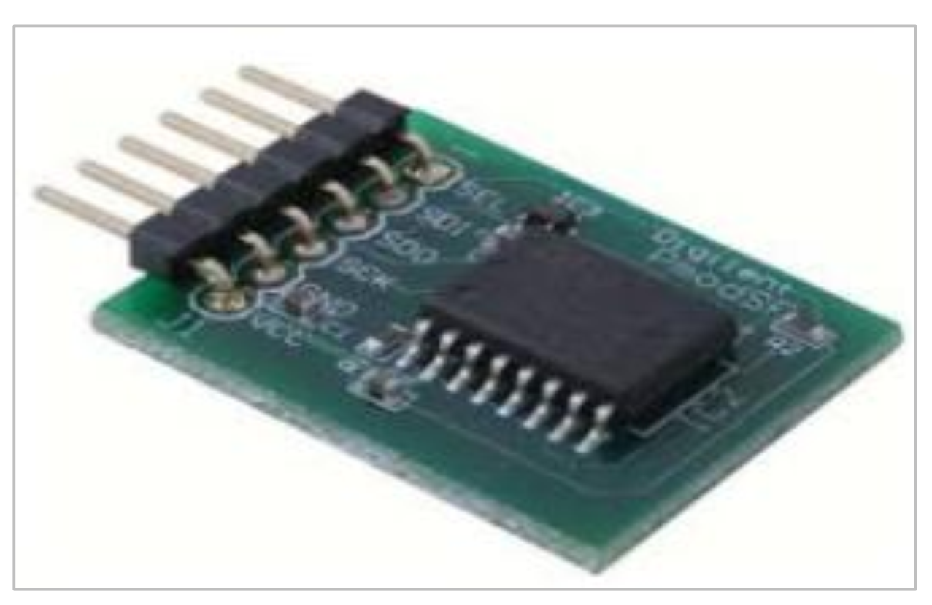
Figure 7: Diagram of ROM

The below table summarized the major differences between RAM and ROM:
S/N | RAM | ROM
 | It is volatile memory. | It is non-volatile memory.
 | The contents are temporary; data is lost when electricity supply is lost. | The contents are permanent; data is not  lost even when power is switched off.
 | Available in small storage capacity. | Available in high storage capacity.
 | Processing speed is high. | Processing speed is low.
 | User-defined programs can be stored. | Generally, operating system supporting  programs can be stored.
 | Cost is very high. | Cost effective.
 | It is of two types, SRAM and DRAM. | It comes in different types such as PROM, EPROM, EEPROM and flash  memory.

Secondary Memory
Sometimes when data to be processed is large, it cannot fit in primary memory as it is limited, in such cases, we use supplement memory or secondary memory. Secondary memory helps to store information permanently and is non-volatile. Examples of secondary storage memory are compact disk, floppy disk, pen drive, external hard drive, etc.

CONCEPT OF HARDWARE AND SOFTWARE
The Computing System
The computing system is made up of the computer system, the user and the environment in which the computer is operated.
The Computer System
The computer system is made up of the hardware and the software. The concept of hardware and software is explained in detail below:
HARDWARE
The term hardware refers to mechanical device that makes up computer. Computer hardware consists of interconnected electronic devices that we can use to control computer’s operation, input and output. Examples of hardware are CPU, keyboard, mouse, hard disk, etc.
Hardware Components
Computer hardware is a collection of several components working together. Some parts are essential and others are added advantages. Computer hardware is made up of CPU and peripherals as shown in image below.
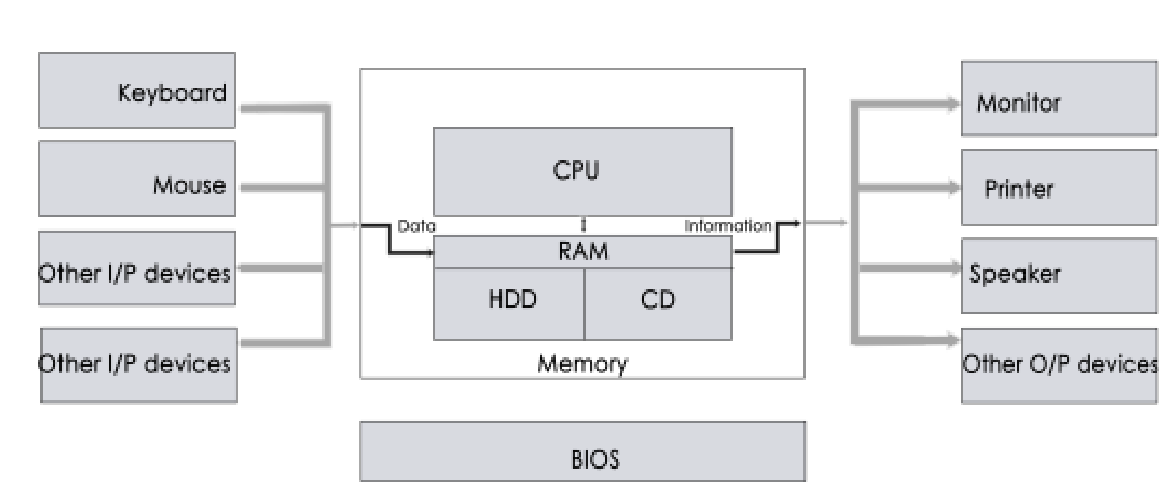
Figure 8: Diagram for hardware components

SOFTWARE
A set of instructions that drives computer to do stipulated tasks is called a program. Software instructions are programmed in a computer language, translated into machine language, and executed by computer. Software can be categorized into two types:
- System software
- Application software

System Software
System software operates directly on hardware devices of computer. It provides a platform to run an application. It provides and supports user functionality. Examples of system software include operating systems such as Windows, Linux, Unix, etc.
Application Software
An application software is designed for benefit of users to perform one or more tasks. Examples of application software include Microsoft Word, Excel, PowerPoint, Oracle, etc.

Differences between Software and Hardware are sorted out below:
S/N | Software | Hardware
- * | It is a collection of programs to bring computer hardware system into operation. | It includes physical components of  computer system.
 | It includes numbers, alphabets, alphanumeric symbols, identifiers, keywords, etc. | It consists of electronic components like  ICs, diodes, registers, crystals, boards,  insulators, etc.
 | Software products evolve by adding new features to existing programs to support hardware. | Hardware design is based on architectural decisions to make it work over a range of environmental conditions and time.
 | It will vary as per computer and its built-in functions and programming language. | It is mostly constructed for all types of  computer systems.
 | It is designed and developed by experienced programmers in high-level language. | The hardware can understand only low-level language or machine language.
 | t is represented in any high-level language such as BASIC, COBOL, C, C++, JAVA, etc. | The hardware works only on binary codes  1’s and 0’s.
 | The software is categorized as operating system, utilities, language processor, application software, etc. | The hardware consists of input devices,  output devices, memory, etc.

Computer users
Computer users are the different categories of personnel that operates the computer. We have expert users and casual users. The expert users could be further categorized into computer engineers, computer programmers and computer operators.
The computing environment
The computing environment ranges from the building housing the other elements of the computing system namely the computer and the users, the furniture, auxiliary devices such as the voltage stabilizer, the Uninterruptible Power Supply System (UPS), the fans, the air conditioners etc. The schematic diagram of the computing system is presented in Figure 9a to Figure 9e.
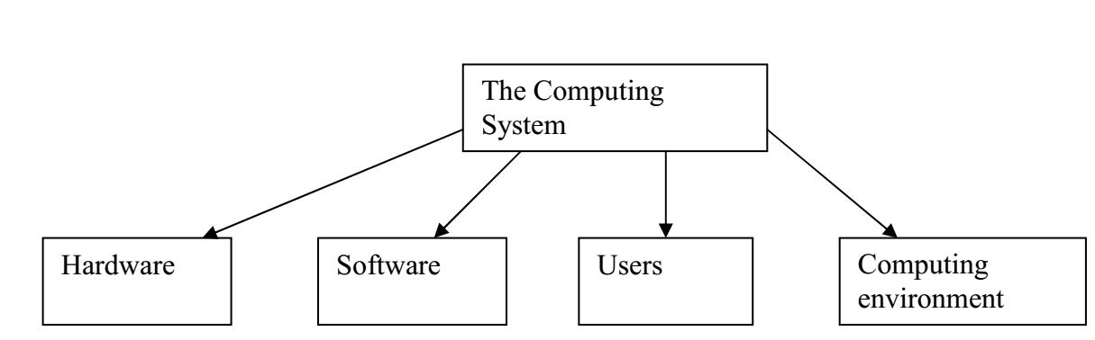
Figure 9a: Schematic diagram of the computing system
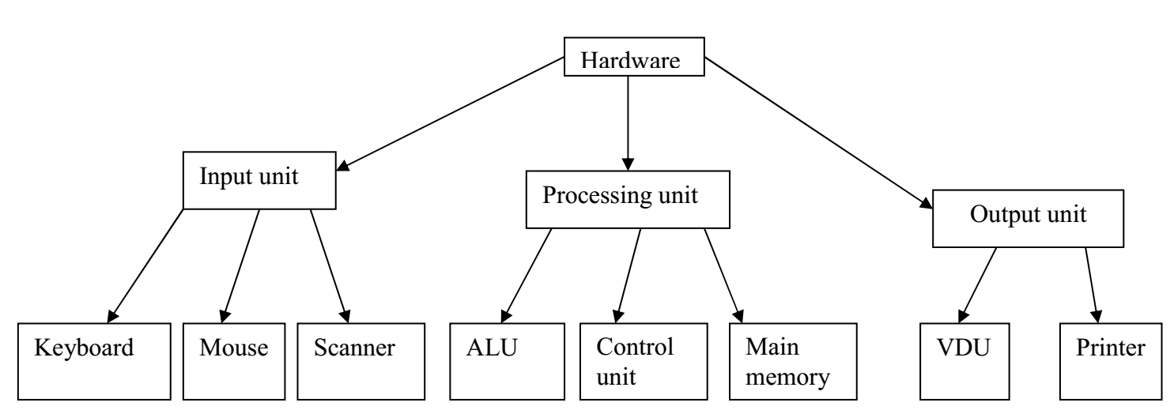
Figure 9b: Computer hardware
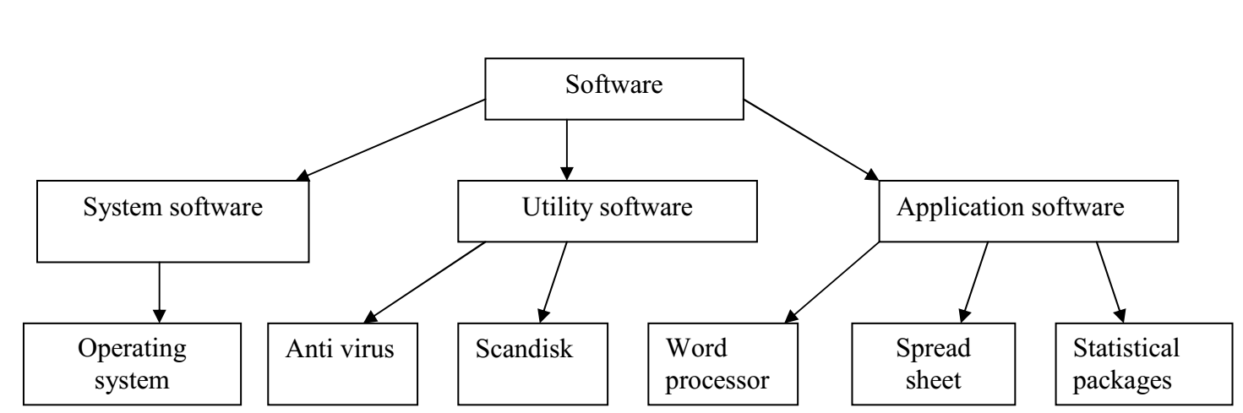
Figure 9c: Computer software

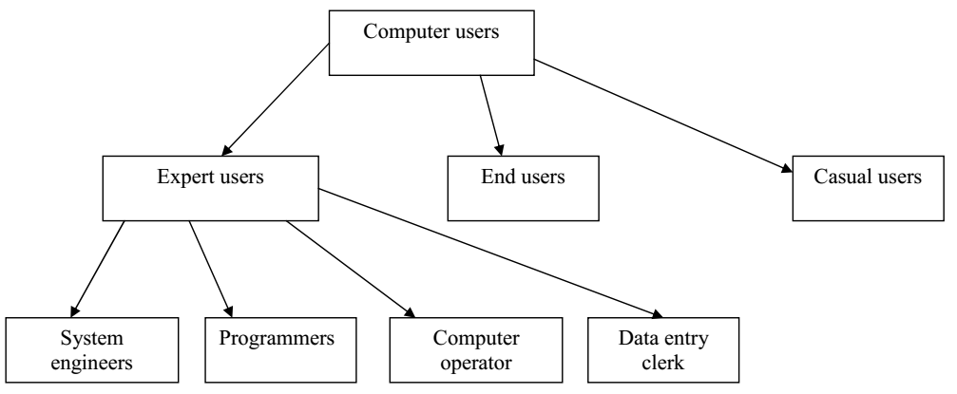
Figure 9d: Computer users
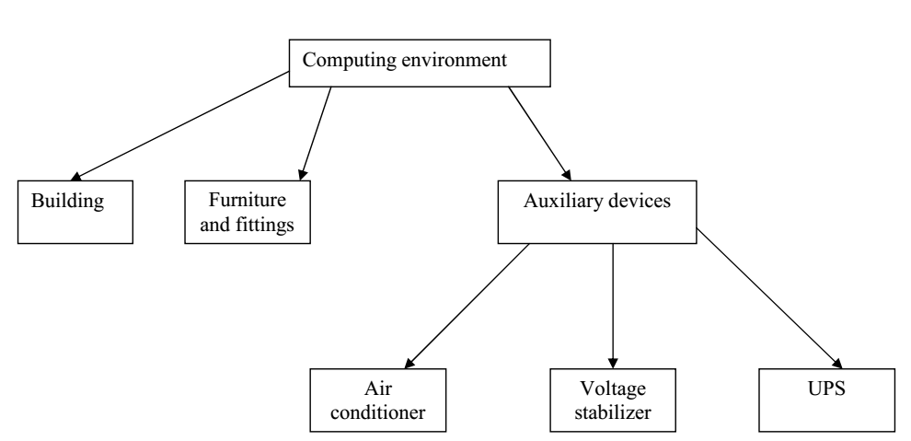
Figure 9e: Computing environment

CLASSIFICATION OF COMPUTERS
The computer has passed through many stages of evolution from the days of the mainframe computers to the era of microcomputers. Computers have been classified based on different criteria. In this unit, we shall classify computers based on three popular methods.
Objectives
The objectives of this unit are to:
i. Classify computers based on size, type of signal and purpose.
ii. Study the features that differentiate one class of the computer from the others.

Categories of Computers
Although there are no industry standards, computers are generally classified in the following ways:
Classification based on signal type
- Digital computer
- Analogue computer
- Hybrid computer
Classification by purpose
- Special purpose
- General purpose

Classification by capacity
- Mainframe
- Mini computers
- Micro computers

CLASSIFICATION BASED ON SIGNAL TYPE
There are basically three types of electronic computers. These are the Digital, analogue and
Hybrid computers.
Digital Computer
Represent its variable in the form of digits. It counts the data it deals with, whether representing numbers, letters or other symbols, are converted into binary form on input to the computer. The data undergoes a processing after which the binary digits are converted back to alphanumeric form for output for human use. Because of the fact that business applications like inventory control, invoicing and payroll deal with discrete values; they are best processed with digital computers. As a result of this, digital computers are mostly used in commercial and business places today.
Analogue Computer
It measures rather than counts. This type of computer represents its variables in terms of electrical voltage and sets up circuit analogue to the equation connecting the variables. The answer can be either by using a voltmeter to read the value of the variable required, or by feeding the voltage into a plotting device. They hold data in the form of physical variables rather than numerical quantities.
In theory, analogue computers give an exact answer because the answer has not been approximated to the nearest digit. Whereas, when we try to obtain the answers using a digital voltmeter, we often find that the accuracy is less than that which could have been obtained from an analogue computer.
It is almost never used in business systems. It is used by the scientist and engineer to solve systems of partial differential equations. It is also used in controlling and monitoring of systems in such areas as hydrodynamics and rocketry; in production.
Hybrid Computer
In some cases, the user may wish to obtain the output from an analogue computer as processed by a digital computer or vice versa. To achieve this, he set up a hybrid machine where the two are connected and the analogue computer may be regarded as a peripheral of the digital computer. In such a situation, a hybrid system attempts to gain the advantage of both the digital and the analogue elements in the same machine. This kind of machine is usually a special-purpose device which is built for a specific task. It needs a conversion element which accepts analogue inputs, and output digital value. Such converters are called digitizers. There is need for a converter from analogue to digital also.
It has the advantage of giving real-time response on a continuous basis. Complex calculations can be dealt with by the digital elements, thereby requiring a large memory, and giving accurate results after programming. They are mainly used in aerospace and process control applications. Examples are MODEM, SIM card etc.

CLASSIFICATION BY PURPOSE
Depending on their flexibility in operation, computers are classified as either special purpose or general purpose.
Special Purpose Computers
A special purpose computer is one that is designed to solve a restricted class of problems. Such computers may even be designed and built to handle only one job. In such machines, the steps or operations that the computer follows may be built into the hardware. Most of the computers used for military purposes fall into this class. Other example of special purpose computers include:
- Computers designed specifically to solve navigational problems.
- Computers designed for tracking airplane or missiles.
- Computers used for process control applications in industries such as oil refinery, chemical manufacture, steel processing and power generation.
- Computers used as robots in factories like vehicles assembly plants and glass industries.
Attributes of Special Purpose Computers
- Special purpose computer are usually very efficient for the tasks for which they are specially designed.
- They are very much less complex than the General-Purpose Computers. The simplicity of the circuiting stems from the fact that provision is made only for limited facilities.
- They are very much cheaper than the General-Purpose type since they involve less components and are less complex.
General-Purpose Computers
General-Purpose computers are computers designed to handle wide range of problems.
Theoretically, a general-purpose computer can be adequate by means of some easily alterable instructions to handle any problems that can be solved by computation. In practice however, there are limitations imposed by memory size, speed and the type of input/output devices. Examples of areas where the general purpose are employed include the following:
- Payroll
- Banking
- Billing
- Sales analysis
- Cost accounting
- Manufacturing scheduling
- Inventory control

Attributes of General-Purpose Computers
- General-Purpose computers are more flexible than special purpose computers.
- They can handle a wide spectrum of problems.
- They are less efficient than the special-purpose computers due to such problems as;
- Inadequate storage;
- Low operating speed;
- Coordination of the various tasks and subsection may take time.
- General Purpose Computers are more complex than the special purpose ones.

CLASSIFICATION OF COMPUTERS ACCORDING TO CAPACITY
In the past, the capacity of computers was measured in terms of physical size. Today, however, the physical size is not a good measure of capacity because the modern technology has made it possible to achieve compactness.
A better measure of capacity today is the volume of work that computer can handle. The volume of work that a given computer handles is closely tied to the cost and to the memory size of computer. Therefore, most authorities today accept the price of rental price as the standard for ranking computers.
Here, both memory size and cost shall be used to rank (classify) computer into three main categories as follows:
(a)Microcomputers
(b)Medium/Mini/Small Computers
(c)Large Computer/Main Frames.
Micro Computers
Microcomputers, also known as single board computers, are the cheapest class of computers. In the microcomputer, we do not have a Central Processing Unit (CPU) as we have in the larger computers rather we have a microprocessor chip as the main data processing unit. They are the cheapest smallest and can operate under normal office condition. Examples are IBM, APPLE, COMPAQ, Hewlett Packard (HP), Dell, Toshiba, etc.
Different Types of Personal Computers (Micro Computers)
Desktop personal computers
Normally, personal computers are placed on table desk hence they are referred to as desktop personal computers. Still other types are available under the categories of personal computers. They are:
Laptop Computers
These are small size types that are battery-operated. The screen is used to cover the system while the keyboard is installed flatly on the system unit. They could be carried about like a box when closed after operation and can be operated in vehicles while on a journey.
Notebook Computer
This is like laptop computers but smaller in size. Though small, it comprises all the components of a full system.
Palmtop Computer
Palmtop computer is far smaller in size. All the components are complete as any of the above but made smaller so that it can be held on the palm.
Uses of Personal Computers
Personal computers can perform the following functions:
- Can be used to produce documents like memos, reports, letters and briefs.
- Can be used to calculate budget and accounting tasks
- It can analyze numeric function
- It can create illustrations
- Can be used for electronic mails
- Can help in making schedule and plan projects.
- It can assist in schedules and plan projects.
- It can assist in searching for specific information from lists or from reports.
Advantages of Personal Computers
- Computer is versatile; it can be used in any establishment.
- Has faster speed for processing data.
- Can deal with several data at a time
- Can attend to several users at the same time, thereby able to process several jobs at a time.
- Capable of storing several data.
- Operating of Computer is less fatigue
- Network possible, that is linking of two or more computers together.
Disadvantages of Personal Computers
- Computer is costly to maintain.
- It is very fragile and complex to handle
- It requires special skill to operate
- With the invention and innovation every day, computer suffers from being obsolete.
- It can lead to unemployment when used mostly in less Developed Countries.
- Some computers cannot function properly without the aid of cooling system e.g. air-condition or fan in some locations.
Mini Computers
The Mini Computers have memory capacity in the range 128K bytes to 256 Kbytes and are also not expensive but reliable and smaller in size compare to mainframe. It was first introduced in 1965; when DEC (Digital Equipment Corporation) built the Personal Data Processor (PDP – 8). Other Mini Computer includes WANG VS.
Mainframe
The Main Frame Computers often called number crunches have memory capacity of the order of 4 Kbytes and they are very expensive. They can execute up to 100MIPS (Meanwhile Instructions Per Second). They have large systems and are used by many people for a variety of purpose.

INTRODUCTION TO PROBLEM SOLVING TECHNIQUES
Learning Objectives
• To understand the concept of Problem solving
• To understand steps involved in algorithm development
• To understand the concept of Algorithm
• Develop Algorithm for simple problem
• To understand the concept of Flowchart development
• Draw the symbols used in Flowcharts
INTRODUCTION
A computer is a very powerful and versatile machine capable of performing a multitude of different tasks, yet it has no intelligence or thinking power. The intelligence of a computer depends on the human intelligence.
In order to instruct a computer correctly, the user must have clear understanding of the problem to be solved. A part from this he should be able to develop a method, in the form of series of sequential steps, to solve it. Once the problem is well-defined and a method of solving it is developed, then instructing the computer to solve the problem becomes relatively easier task.
Thus, before attempt to write a computer program to solve a given problem. It is necessary to formulate or define the problem in a precise manner. Once the problem is defined, the steps required to solve it, must be stated clearly in the required order.
PROCEDURE (STEPS INVOLVED IN PROBLEM SOLVING)
A computer cannot solve a problem on its own. One has to provide step by step solutions of the problem to the computer. In fact, the task of problem solving is not that of the computer. It is the programmer who has to write down the solution to the problem in terms of simple operations which the computer can understand and execute.
In order to solve a problem by the computer, one has to pass though certain stages or steps. They are:
1. Understanding the problem
2. Analyzing the problem
3. Developing the solution
4. Coding and implementation.
1. Understanding the problem: Here we try to understand the problem to be solved totally. Before with the next stage or step, we should be absolutely sure about the objectives of the given problem.
2. Analyzing the problem: After understanding thoroughly the problem to be solved, we look at different ways of solving the problem and evaluate each of these methods. The idea here is to search an appropriate solution to the problem under consideration. The end result of this stage is a broad overview of the sequence of operations that are to be carried out to solve the given problem.
3. Developing the solution: Here the overview of the sequence of operations that was the result of analysis stage is expanded to form a detailed step by step solution to the problem under consideration.
4. Coding and implementation: The last stage of the problem solving is the conversion of the detailed sequence of operations into a language that the computer can understand. Here each step is converted to its equivalent instruction or instructions in the computer language that has been chosen for the implementation.

ALGORITHM
Definition
A set of sequential steps usually written in Ordinary Language to solve a given problem is called Algorithm.
It may be possible to solve to problem in more than one ways, resulting in more than one algorithm. The choice of various algorithms depends on the factors like reliability, accuracy and easy to modify. The most important factor in the choice of algorithm is the time requirement to execute it, after writing code in High-level language with the help of a computer. The algorithm which will need the least time when executed is considered the best.
Steps involved in algorithm development
An algorithm can be defined as “a complete, unambiguous, finite number of logical steps for solving a specific problem “.
Step1. Identification of input: For an algorithm, there are quantities to be supplied called input and these are fed externally. The input is to be identified first for any specified problem.
Step2: Identification of output: From an algorithm, at least one quantity is produced, called for any specified problem.
Step3 : Identification the processing operations : All the calculations to be performed in order to lead to output from the input are to be identified in an orderly manner.
Step4 : Processing Definiteness : The instructions composing the algorithm must be clear and there should not be any ambiguity in them.
Step5 : Processing Finiteness : If we go through the algorithm, then for all cases, the algorithm should terminate after a finite number of steps.
Step6 : Possessing Effectiveness : The instructions in the algorithm must be sufficiently basic and in practice they can be carries out easily.
An algorithm must possess the following properties
1. Finiteness: An algorithm must terminate in a finite number of steps
2. Definiteness: Each step of the algorithm must be precisely and unambiguously stated
3. Effectiveness: Each step must be effective, in the sense that it should be primitive easily convert able into program statement) can be performed exactly in a finite amount of time.
4. Generality: The algorithm must be complete in itself so that it can be used to solve problems of a specific type for any input data.
5. Input/output: Each algorithm must take zero, one or more quantities as input data produce one or more output values. An algorithm can be written in English like sentences or in any standard representation sometimes, algorithm written in English like languages are called Pseudo Code.

Example
1. Suppose we want to find the average of three numbers, the algorithm is as follows
Step 1 Read the numbers a, b, c
Step 2 Compute the sum of a, b and c
Step 3 Divide the sum by 3
Step 4 Store the result in variable d
Step 5 Print the value of d
Step 6 End of the program

2. Write an algorithm to calculate the simple interest using the formula. Simple interest = P*N* R/100.
Where P is principle Amount, N is the number of years and R is the rate of interest.
Step 1: Read the three input quantities’ P, N and R.
Step 2 : Calculate simple interest as
Simple interest = P* N* R/100
Step 3: Print simple interest.
Step 4: Stop.
3. Area of Triangle: Write an algorithm to find the area of the triangle.
Let b, c be the sides of the triangle ABC and A the included angle between the given sides.
Step 1: Input the given elements of the triangle namely sides b, c and angle between the sides A.
Step 2: Area = (1/2) *b*C* sin A
Step 3: Output the Area
Step 4: Stop.
4. Write an algorithm to find the largest of three numbers X, Y,Z.
Step 1: Read the numbers X,Y,Z.
Step 2: if (X > Y)
Big = X
else BIG = Y
Step 3 : if (BIG < Z)
Step 4: Big = Z
Step 5: Print the largest number i.e. Big
Step 6: Stop.

FLOW CHART
A flow chart is a step-by-step diagrammatic representation of the logic paths to solve a given problem. Or A flowchart is visual or graphical representation of an algorithm.
The flowcharts are pictorial representation of the methods to be used to solve a given problem and help a great deal to analyze the problem and plan its solution in a systematic and orderly manner. A flowchart when translated in to a proper computer language, results in a complete program.
Advantages of Flowcharts
1. The flowchart shows the logic of a problem displayed in pictorial fashion which felicitates easier checking of an algorithm.
2. The Flowchart is good means of communication to other users. It is also a compact means of recording an algorithm solution to a problem.
3. The flowchart allows the problem solver to break the problem into parts. These parts can be connected to make master chart.
4. The flowchart is a permanent record of the solution which can be consulted at a later time.
Differences between Algorithm and Flowchart
Algorithm | Flowchart
1. A method of representing the step-by-step logical procedure for solving a problem | 1. Flowchart is diagrammatic representation of an algorithm. It is constructed using different types of boxes and symbols.
2. It contains step-by-step English descriptions, each step representing a particular operation leading to solution of problem | 2. The flowchart employs a series of blocks  and arrows, each of which represents a  particular step in an algorithm
3. These are particularly useful for small problems | 3. These are useful for detailed representations of complicated programs
4. For complex programs, algorithms prove to be Inadequate | 4. For complex programs, Flowcharts prove to be adequate

SYMBOLS USED IN FLOW CHARTS
The symbols that we make use while drawing flowcharts as given below are as per conventions followed by International Standard Organization (ISO).
a. Oval: Rectangle with rounded sides is used to indicate either START/ STOP of the program.

b. Input and output indicators: Parallelograms are used to represent input and output operations. Statements like INPUT, READ and PRINT are represented in these Parallelograms.
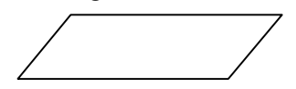
c. Process Indicators: - Rectangle is used to indicate any set of processing operation such as for storing arithmetic operations.
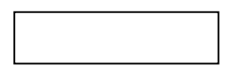
d. Decision Makers: The diamond is used for indicating the step of decision making and therefore known as decision box. Decision boxes are used to test the conditions or ask questions and depending upon the answers, the appropriate actions are taken by the computer. The decision box symbol is
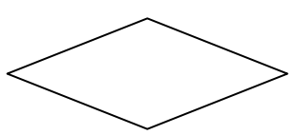
e. Flow Lines: Flow lines indicate the direction being followed in the flowchart. In a Flowchart, every line must have an arrow on it to indicate the direction. The arrows may be in any direction
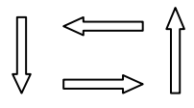
f. On- Page connectors: Circles are used to join the different parts of a flowchart and these circles are called on-page connectors. The uses of these connectors give a neat shape to the flowcharts. Ina complicated problems, a flowchart may run in to several pages. The parts of the flowchart on different pages are to be joined with each other. The parts to be joined are indicated by the circle.
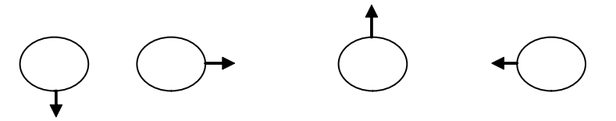

SIMPLE PROBLEMS USING FLOW CHART
Draw the Flowchart for the following
- Draw a flowchart to find out the biggest of the three unequal positive numbers.
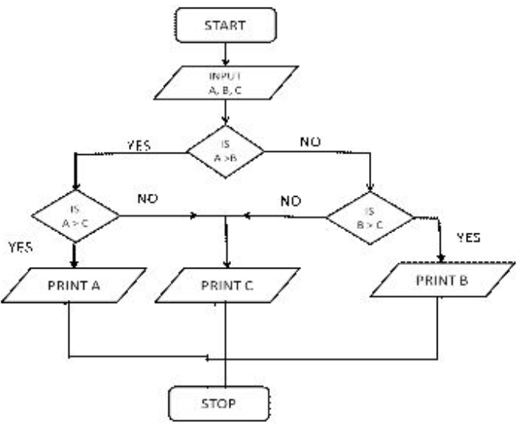
- Draw a flowchart for adding the integers from 1 to 100 and to print the sum.
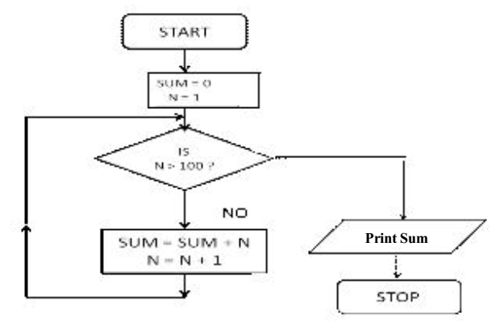
PSEUDO CODE
The Pseudo code is neither an algorithm nor a program. It is an abstract form of a program. It consists of English like statements which perform the specific operations. It is defined for an algorithm. It does not use any graphical representation. In pseudo code, the program is represented in terms of words and phrases, but the syntax of program is not strictly followed.
Advantages: * Easy to read, * Easy to understand, * Easy to modify.
Example: Write a pseudo code to perform the basic arithmetic operations.
Read n1, n2
Sum = n1 + n2
Diff = n1 – n2
Mult = n1 * n2
Quot = n1/n2
Print sum, diff, mult, quot
End.

DATA COMMUNICATION AND NETWORK
Data communication
Data communications simply refers to a set of computer system that uses telecommunications for the exchange of data or information.
Data communications are the exchange of data between two devices via some form of transmission medium such as a wire cable. For data communications to occur, the communicating devices must be part of a communication system made up of a combination of hardware (physical equipment) and software (programs).
It is clear from the above that data communication involves an interconnectivity of various computer hardware in a special way which can be describes as (topology), coupled with some laid down set of rules and regulation which guides the initiation of data transmission (protocols). The data transmission process is a function of the medium (communication channels), speed, direction and mode which is called transmission characteristics.
The data communication architecture is made up of both hardware and software components. The hardware components include the following: keyboard, modem, Network Interface Card (NIC), routers, bridges, and intelligent PC while the software component comprises of the following: network protocols and operating systems which guides the conversion of digital codes to electronic signals and vice versa.
Communication channels
Communications channels unite data communication hardware and provide a physical pathway for the exchange of data. This physical medium is the most critical link in the data communication system. If the link is broken, the message dies.
Communication channels are built on four basic principles: physical medium, transmission characteristics, protocol and topology.
Transmission characteristics
The transmission characteristics of the communication channels determine the system’s performance. These computers can be divided into three functional groups: transmission speed, transmission direction and transmission mode.
Transmission speed
The transmission speed of a communication channel determines how much data can be transmitted over the physical medium in a given period of time. This rate is usually measured in bits per second or bps.
Transmission direction
The transmission direction of a communication channel refers to the ability of the media to handle simultaneous transmission.

Simplex
In simplex mode, the communication is unidirectional, as on a one-way street. Only one of the two devices on a link can transmit; the other can only receive. Keyboards and traditional monitors are examples of simplex devices. The keyboard can only introduce input; the monitor can only accept output. The simplex mode can use the entire capacity of the channel to send data in one direction.
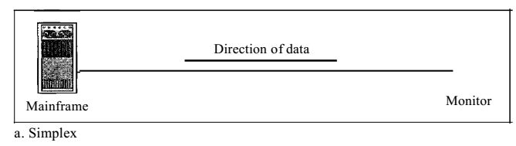
Figure 10a. Simplex

Half-Duplex
In half-duplex mode, each station can both transmit and receive, but not at the same time. When one device is sending, the other can only receive, and vice versa.
The half-duplex mode is like a one-lane road with traffic allowed in both directions. When cars are traveling in one direction, cars going the other way must wait. In a half-duplex transmission, the entire capacity of a channel is taken over by whichever of the two devices is transmitting at the time. Walkie-talkies and CB (citizens band) radios are both half-duplex systems.
The half-duplex mode is used in cases where there is no need for communication in both directions at the same time; the entire capacity of the channel can be utilized for each direction.
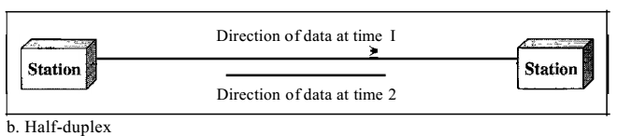
Figure 10b. Half-duplex

Full-Duplex
In full-duplex (also called duplex), both stations can transmit and receive simultaneously. One common example of full-duplex communication is the telephone network. When two people are communicating by a telephone line, both can talk and listen at the same time.
The full-duplex mode is used when communication in both directions is required all the time. The capacity of the channel, however, must be divided between the two directions.
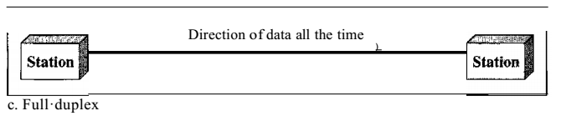
Figure 10c. Full-duplex

Transmission mode
The transmission mode of a communication channel refers to the bit-level organization of the data and the way it is transmitted over the physical medium. The two common modes of transmission are asynchronous and synchronous transmissions.
Asynchronous transmission
An asynchronous transmission involves the sending of one character (or byte) at a time. To separate the characters, a start bit and one or more stop bits are added to each end of the individual 8-bit character code. This mode of transmission is slow and wasteful because the system must support 11 bits per byte instead of the standard 8 bits.
Synchronous
A synchronous transmission involves the sending of organized blocks of characters, sometimes called frames or packets. These packets of data are carefully synchronized so that the sending and receiving devices can distinguish the boundaries of each character. This mode is faster and more efficient.

Components
A data communications system has five components.
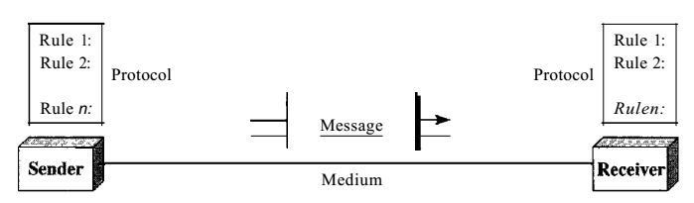
Figure 11. Components of data communication system

- Message. The message is the information (data) to be communicated. Popular forms of information include text, numbers, pictures, audio, and video.
- Sender. The sender is the device that sends the data message. It can be a computer, workstation, telephone handset, video camera, and so on.
- Receiver. The receiver is the device that receives the message. It can be a computer, workstation, telephone handset, television, and so on.
- Transmission medium. The transmission medium is the physical path by which a message travels from sender to receiver. Some examples of transmission media include twisted-pair wire, coaxial cable, fiber-optic cable, and radio waves.
- Protocol. A protocol is a set of rules that govern data communications. It represents an agreement between the communicating devices. Without a protocol, two devices may be connected but not communicating.

Data Representation
Information today comes in different forms such as
- Text
- Numbers
- Images
- Audio, and
- Video

Types of networks
There are 3 main types of networks
- Local Area Network (LAN): A LAN is usually privately owned and links the devices in a single office, building, or campus.
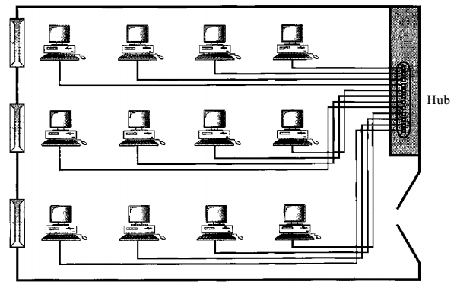
Figure 12. An isolated IAN connecting 12 computers to a hub in a closet

- Wide Area Network. A wide area network (WAN) provides long-distance transmission of data, image, audio, and video information over large geographic areas that may comprise a country, a continent, or even the whole world.
- Metropolitan Area Networks. A metropolitan area network (MAN) is a network with a size between a LAN and a WAN. It normally covers the area inside a town or a city. It is designed for customers who need a high-speed connectivity, normally to the Internet, and have endpoints spread over a city or part of city. A good example of a MAN is the part of the telephone company network that can provide a high-speed DSL line to the customer. Another example is the cable TV network that originally was designed for cable TV, but today can also be used for high-speed data connection to the Internet.

Interconnecting devices
LANs, WANs, and MANs each speak their own language; the process of connecting multiple dissimilar systems requires very flexible advanced interconnecting devices, these devices include:
- Repeater: Repeaters are simple interconnecting devices that connect two identical cabling segments of a LAN. A repeater accepts weak signals and electrically regenerates them and then sends the messages back on their way.
- Bridges: Bridges are more intelligent than repeaters, they go beyond simply regenerating weak signals. Bridges process network signals and ensure smooth passage from LAN to LAN and from LAN to WAN.
- Routers: Routers contain advanced algorithms that allow them to make intelligent decisions about where a message should go and what path to use for greater efficiency.
- Gateways: Gateways approach interconnectivity from a completely different angle. These devices use more of software translation than hardware routing. They are required when network messages travel between two entirely different systems.

Protocols
In computer networks, communication occurs between entities in different systems. An entity is anything capable of sending or receiving information. However, two entities cannot simply send bit streams to each other and expect to be understood. For communication to occur, the entities must agree on a protocol. A protocol is a set of rules that govern data communications. A protocol defines what is communicated, how it is communicated, and when it is communicated.
The sole purpose of protocol is to provide guidance to the communication channels and to promote harmonious connectivity between the many network components. Protocols work on the electronic level. They are initiated and controlled by advanced subroutines built into each NIC.
LANs commonly use one of three communications protocols: CSMA, polling and token passing.

CSMA
CSMA stands for Carrier Sense Multiple Access. CSMA relies on a share trunk of cabling; the trunk is a single run of cabling that extends throughout the topology of the LAN. Here is how the protocol works:
- Workstation A has a message for workstation B. Workstation A listens to the trunk and waits until all is clear (Carrier Sensing).
- When A detects that the trunk is clear, the workstation marks the message with a destination address and sends it over the trunk. All other workstations continually monitor the trunk for a message with their address (multiple access).
- Workstation B finds a match, accepts the message and returns an acknowledgement of receipt.

Polling
Polling refers on a central controlling node (workstation or file server). The central node polls each station to determine whether there is a message to be sent. When a sending workstation is ready, the central node reserves the network channel and the message is sent. Polling is typically used in a centralized system because this type of protocol relies exclusively on the intelligence and dexterity of the central controlling node.

Token passing
In the token-passing method, the stations in a network are organized in a logical ring. In other words, for each station, there is a predecessor and a successor. The predecessor is the station which is logically before the station in the ring; the successor is the station which is after the station in the ring. The current station is the one that is accessing the channel now. The right to this access has been passed from the predecessor to the current station. The right will be passed to the successor when the current station has no more data to send.
But how is the right to access the channel passed from one station to another? In this method, a special packet called a token circulates through the ring. The possession of the token gives the station the right to access the channel and send its data. When a station has some data to send, it waits until it receives the token from its predecessor. It then holds the token and sends its data. When the station has no more data to send, it releases the token, passing it to the next logical station in the ring. The station cannot send data until it receives the token again in the next round. In this process, when a station receives the token and has no data to send, it just passes the data to the next station.

TYPES OF TOPOLOGIES
Type of Connection
A network is two or more devices connected through links. A link is a communications pathway that transfers data from one device to another.

Point-to-Point
A point-to-point connection provides a dedicated link between two devices. The entire capacity of the link is reserved for transmission between those two devices.
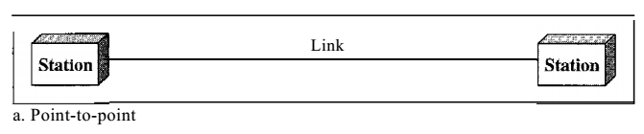
Figure 13a. Point-to-point

Multipoint
A multipoint (also called multidrop) connection is one in which more than two specific devices share a single link.
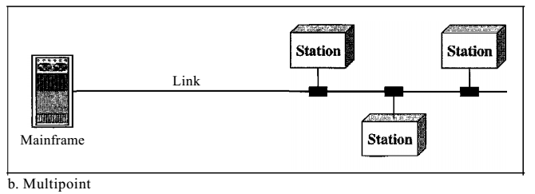
Figure 13b. Multipoint

Mesh
In a mesh topology, every device has a dedicated point-to-point link to every other device. The term dedicated means that the link carries traffic only between the two devices it connects. To find the number of physical links in a fully connected mesh network with n nodes, we first consider that each node must be connected to every other node.
Advantages
- First, the use of dedicated links guarantees that each connection can carry its own data load, thus eliminating the traffic problems that can occur when links must be shared by multiple devices.
- Second, a mesh topology is robust. If one link becomes unusable, it does not incapacitate the entire system.
- Third, there is the advantage of privacy or security. When every message travels along a dedicated line, only the intended recipient sees it.
- Finally, point-to-point links make fault identification and fault isolation easy.

Disadvantages
The main disadvantages of a mesh are related to the amount of cabling and the number of I/O ports required.
- First, because every device must be connected to every other device, installation and reconnection are difficult.
- Second, the sheer bulk of the wiring can be greater than the available space (in walls, ceilings, or floors) can accommodate.
- Finally, the hardware required to connect each link (I/O ports and cable) can be prohibitively expensive.
One practical example of a mesh topology is the connection of telephone regional offices in which each regional office needs to be connected to every other regional office.
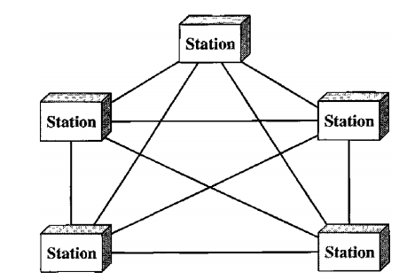
Figure 14. Mesh

Star Topology
In a star topology, each device has a dedicated point-to-point link only to a central controller, usually called a hub. The devices are not directly linked to one another.
Advantages
- Less expensive than a mesh topology.
- Easy to install and reconfigure.
- Far less cabling needs to be housed, and additions, moves, and deletions involve only one connection: between that device and the hub.
- Robustness. If one link fails, only that link is affected. All other links remain active. This factor also lends itself to easy fault identification and fault isolation.
Disadvantages
- The dependency of the whole topology on one single point, the hub. If the hub goes down, the whole system is dead.
- Often more cabling is required in a star than in some other topologies (such as ring or bus).
- The star topology is used in local-area networks (LANs). High-speed LANs often use a star topology with a central hub.
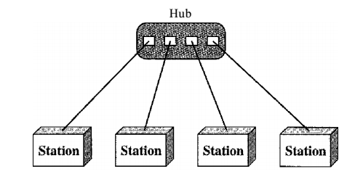
Figure 15. Star

Bus Topology
The preceding examples all describe point-to-point connections. A bus topology, on the other hand, is multipoint. One long cable act as a backbone to link all the devices in a network. Nodes are connected to the bus cable by drop lines and taps. A drop line is a connection running between the device and the main cable. A tap is a connector that either splices into the main cable or punctures the sheathing of a cable to create a contact with the metallic core.
As a signal travels along the backbone, some of its energy is transformed into heat. Therefore, it becomes weaker and weaker as it travels farther and farther. For this reason, there is a limit on the number of taps a bus can support and on the distance between those taps.
Advantages
- Ease of installation.
- Redundancy is eliminated. Only the backbone cable stretches through the entire facility.
Disadvantages
- Difficult reconnection and fault isolation.
- A fault or break in the bus cable stops all transmission, even between devices on the same side of the problem.
Bus topology was the one of the first topologies used in the design of early local area networks.
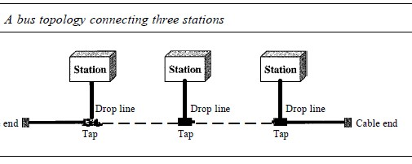
Figure 16. Bus

Ring Topology
In a ring topology, each device has a dedicated point-to-point connection with only the two devices on either side of it. A signal is passed along the ring in one direction, from device to device, until it reaches its destination. Each device in the ring incorporates a repeater. When a device receives a signal intended for another device, its repeater regenerates the bits and passes them along.
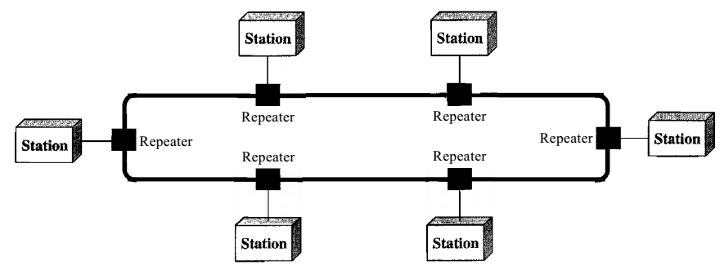
Figure 17. Ring

Advantages
- Relatively easy to install and reconfigure.
- Fault isolation is simplified. Generally, in a ring, a signal is circulating at all times. If one device does not receive a signal within a specified period, it can issue an alarm. The alarm alerts the network operator to the problem and its location.
Disadvantages
- Unidirectional traffic.
- In a simple ring, a break in the ring (such as a disabled station) can disable the entire network. This weakness can be solved by using a dual ring or a switch capable of closing off the break.

Hybrid Topology
A network can be hybrid. For example, we can have a main star topology with each branch connecting several stations in a bus topology.
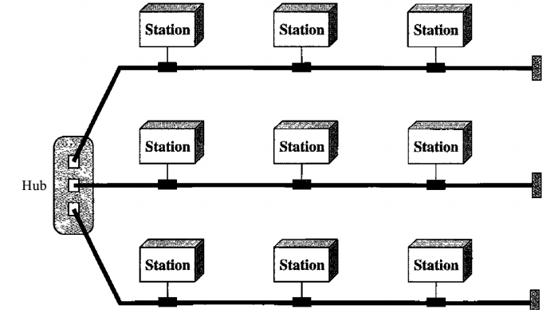

Figure 18. Hybrid
OFFICE APPLICATION SOFTWARE
MICROSOFT EXCEL
INTRODUCTION
Microsoft Excel is a spreadsheet program designed by Microsoft Corporation for spreadsheet analysis. The spreadsheet is made of columns and rows similar to accounting worksheets. This program is generally used by all managers, accountants, bankers, cashiers etc. This enable them to adequately process and manage their daily generated data.
Some of the functions of spreadsheet packages include:
- Ability to perform calculation, with automatic summation facility.
- Ability to update formula cells
- Various formatting facilities to format workbook
- Input data validation strategies
- Chart creations
- Auditing worksheets etc.
Features of MS Excel
- Workbook- A workbook is the file equivalent of the spreadsheet package on which work is performed and data are stored. The workbook is made up of several worksheets, which allows various kinds of related information to be organized in a single workbook.
- Active sheet-The active sheet is the worksheet where you are currently working on in a workbook. The sheet tab of the active sheet is highlighted on the worksheet bar.
- Cell- A cell is the intersection of a row and column. A cell is addressed by using its cell address e.g. B1, C5, H2 etc.
- Cell address or Reference- The columns in a worksheet are labelled with alphabetic characters A, B, C, ……, while the rows are labelled with numeric values 1, 2, 3, 4….. A cell is addressed or referenced by using the column letter with its corresponding row value e.g. B1, C5, K4, etc.
- Range- A range is a rectangular block of cells. A range can consist of a single cell, some selected cells, an entire worksheets or all the worksheets in a workbook.
- Range address- A range is identified by its address. A range address or reference consists of the top left and bottom right cells in the range, separated by two periods or colon e.g. A1..H20, B2:K4, C5:D8 etc.
- Chart- Charts are used to graphically present data. Reports presented with the aid of charts are always brief and comparison can easily be made among grouped data. Charts are of different types (Bar, Pie, Area, Line, etc.) and the choice of any of the chart is greatly influenced by the type of report to present.
- Chart sheet- This is a sheet in a workbook that contains only a chart. This sheet is labelled with Chart1, Chart2, Chart3 etc. to distinguish it from worksheets. Chart sheets are linked to their respective worksheet data and they are updated automatically whenever changes are made to the source data.
- Formula- Formula is written to perform arithmetic operations such as addition (+), subtraction (-), multiplication (*), and division (/). The formula is written once and copied to other cells in return. A formula is preceded by a formula indicator, a symbol such as “=” e.g. = SUM (E4:F8), =(D4*4)-E2 etc.
- Formula Bar- The formula bar appears at the top of a spreadsheet window, it can be used to enter or edit values or formulas in cells. In general, content of the active cell is displayed on the formula bar.
- Operators- Operators are used in a formula to indicate action to be performed on the arguments (operands). Basic operators in excel include addition (+), subtraction (-), multiplication (*), division (/) and exponentiation (^).
- Functions- Functions are pre-written (in-built) formulas use to perform some standard computations. Examples of functions are sum, product, average, maximum, minimum, sin, standard deviation etc. For example, = SUM(C3:D8) will return the result of addition of the contents of cell C3 to D8, =SIN(30) return the sin of an angle 30.

HANDS-ON
The students should be introduced to practical in MS Excel such as Formulas, SUM, Percentage, IF, Nested IF, AND, OR functions etc.

MICROSOFT WORD/WORD PROCESSOR
DEFINITION OF MICROSOFT WORD
This is an application package designed for typing of document and for graphical designing. Microsoft word belongs to a family called the Microsoft office.
Microsoft office is a program designed by micro-soft companies and has Microsoft attached to their names. E.g. Microsoft word, Microsoft PowerPoint, Microsoft Excel, Microsoft Access Etc.
In other words, a word processor is a device or computer program that provides for input, editing, formatting, and output of text, often with some additional features.

Creating a Document
When a new document is created it has to be formatted to look attractive and presentable. This determines how the document will look like when finished and printed. The author of the document could decide to format the document before or after typing.
Steps to Create a blank document
- Open Word. Or, if Word is already open, select File > New.
- Select Blank document.
Exercise 1: Type the following passage
New rules to Rationale management;
Foremost: Rationale is the justification of decisions. Rationale models represents the reasoning that leads to the decisions, including its functionality- and its implementation. Rationale is critical in two areas: It supports the decisions making and it supports the capture of knowledge. Rationale includes:
- The issues that were addressed
- The alternatives that were considered
- The decisions that were made to resolve the issues
- The criteria that were used to guide decisions
In the context of decision making the rationale improves the quality of decisions by making decision elements, such as criteria, priorities, and arguments, explicit. In the context of knowledge capture, the rationale is the most important information in the development process.

Saving a Document
It is good to cultivate the habit of saving one’s work periodically while typing to avoid loss of information in case of an interrupted power supply.
To save, follow the steps below:
- Select File from the Menu
- Select Save As. A dialogue box appears as shown below:
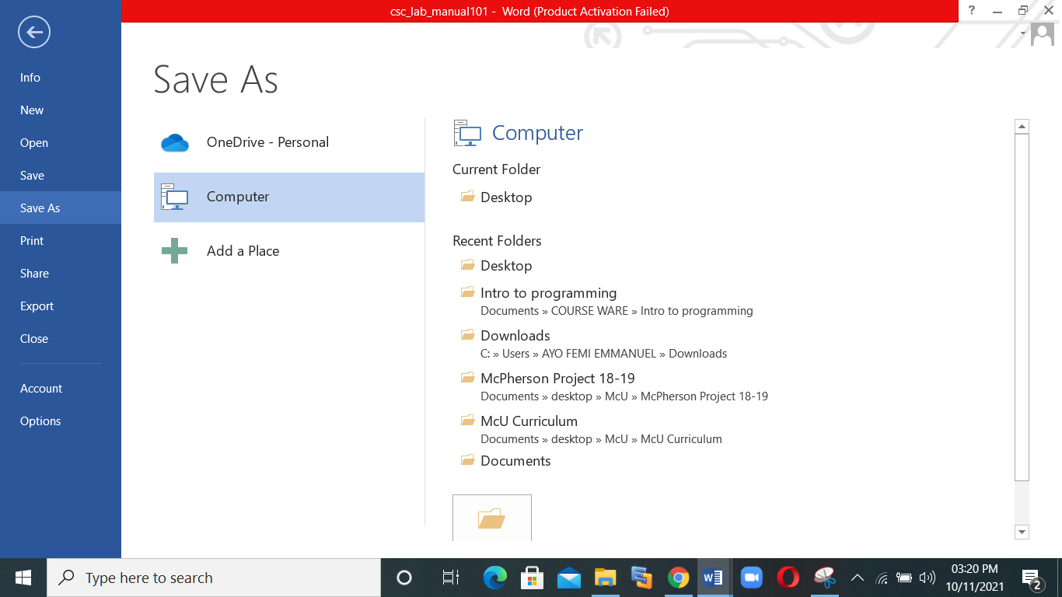

- Select the location to save e.g. desktop, documents etc.

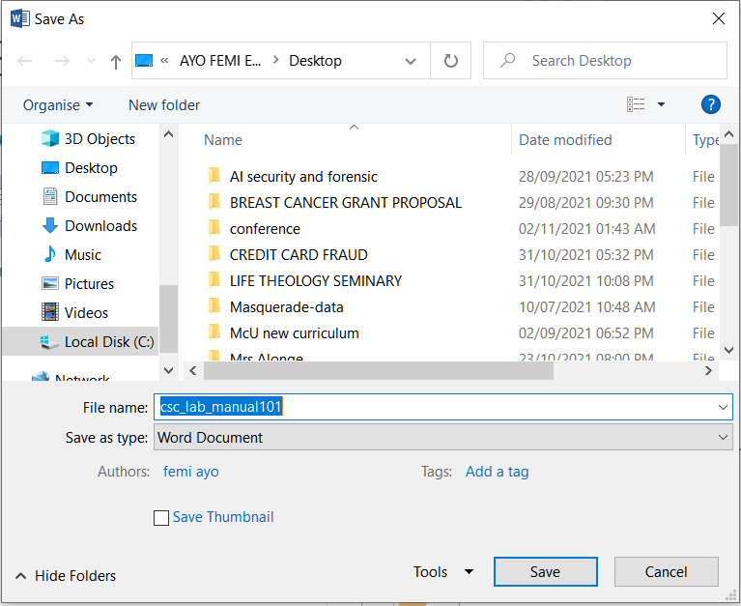

- Give a name to the document and click the Save button

Some Important Terminology
Soft Return
As you are typing in the document, the moment the cursor gets to the end of the line it automatically moves to the next line.
Hard Return
This is when the cursor manually moved to the beginning of the next line by pressing the ENTER key.

Word Art
Use text art to change words in your documents into designs. Word Art designs are graphic images. They are contained in a graphics box in MS word.

How to Insert WordArt
Word Art is designed to allow you make your text more attractive; you can format your text to make it look like a picture and enhance its appearance in different ways. The steps to insert WordArt are given below;
- Place the cursor where you want to insert WordArt
- Select the Insert tab
- In Text group click the 'WordArt' button
- WordArt menu appears;
- Select the desired WordArt style
- 'Edit WordArt Text' dialog box appears
- Type the text in text area and click OK

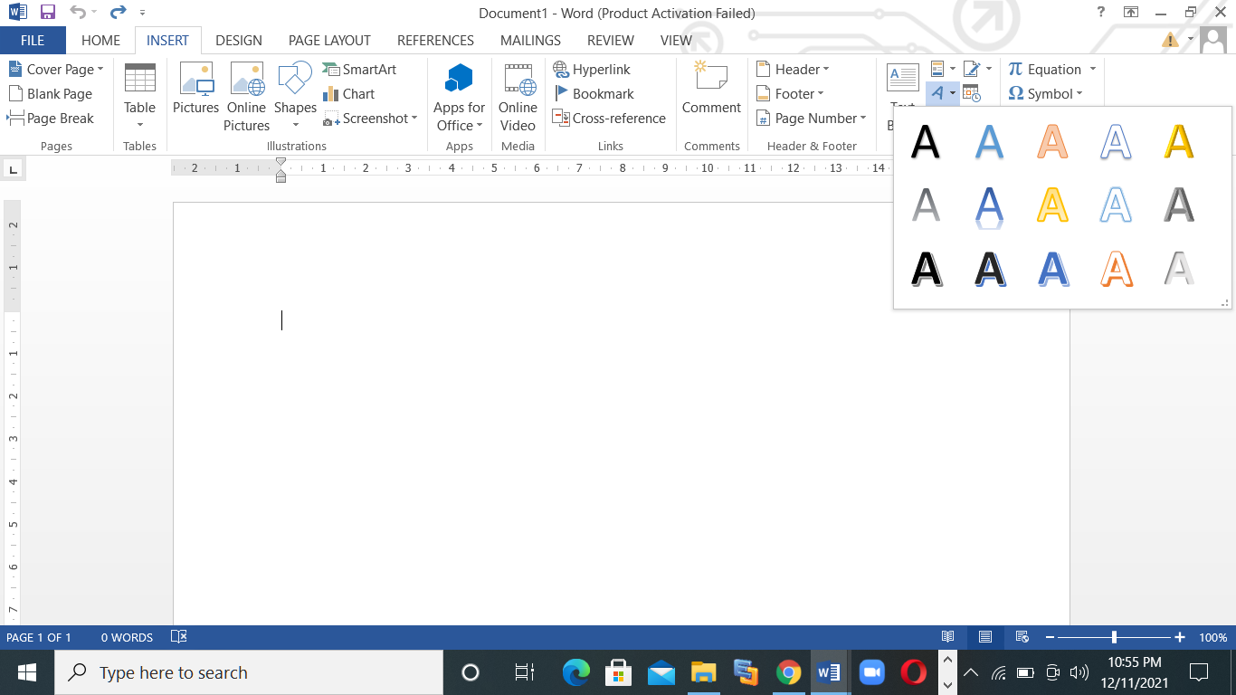

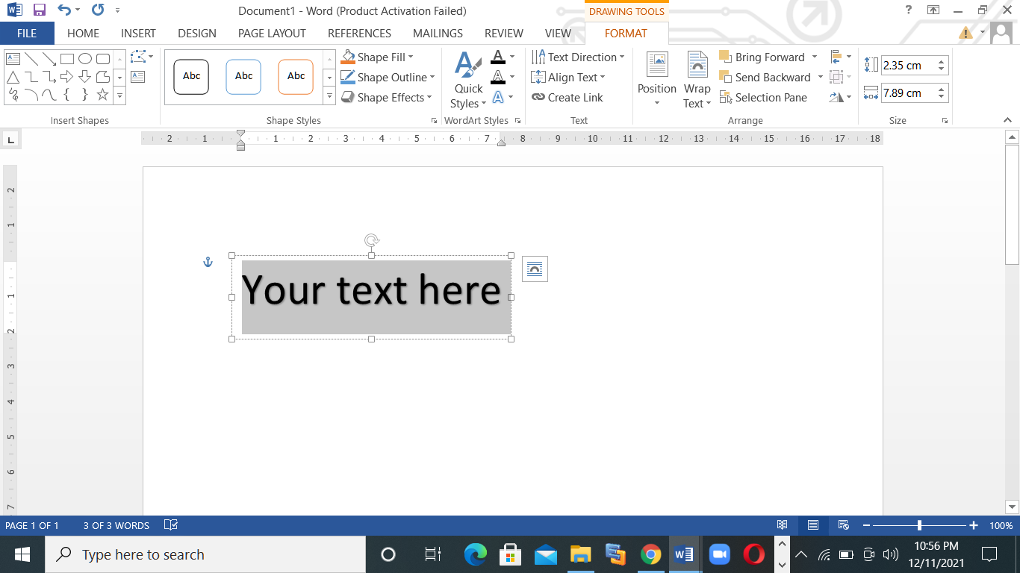

How to create Drop Cap
A
drop cap (dropped capital) is a large capital letter used as a decorative element at the beginning of a paragraph or section. The size of a drop cap is usually two or more lines.
Add a drop cap
- Select the first character of a paragraph.
- Go to INSERT > Drop Cap.
- Select the drop cap option you want.
- To create a drop cap that fits within your paragraph, select Dropped.
- To create a drop cap that is in the margin, outside of your paragraph, select In margin.
Remove a drop cap
- Highlight the large drop cap letter.
- Go to INSERT > Drop Cap, and select None.

MAIL MERGE
Mail merge is an MS word feature that lets you create letters for a number of people without typing the original letter more than once. The letter is saved in a separate file called form file. A letter form file contains all the formatting information, text, and graphics you want to be common to each other. Next you create the data file that contains all the names and addresses that should go with the letter. Finally, in order to create the complete letters, you merge the form file with the data file.

Steps to create Mail Merge
- In a blank Microsoft Word document, click on the Mailings tab, and in the Start Mail Merge group, click Start Mail Merge.
- Click Step-by-Step Mail Merge Wizard
- Select your document type. In this demo we will select Letters. Click Next: Starting document.
- Select the starting document. In this demo we will use the current (blank) document. Select Use the current document and then click Next: Select recipients.
- Select recipients. In this demo we will create a new list, so select Type a new list and then click Create.
- Create a list by adding data in the New Address List dialog box and clicking OK.
- Save the list.
- Note that now that a list has been created, the Mail Merge Wizard reverts to Use an existing list and you have the option to edit the recipient list.
- Selecting Edit recipient list opens up the Mail Merge Recipients dialog box, where you can edit the list and select or unselect records. Click OK to accept the list as is.
- Click Next: Write your letter.
- Write the letter and add custom fields.
- Click Address block to add the recipients' addresses at the top of the document.
- In the Insert Address Block dialog box, check or uncheck boxes and select options on the left until the address appears the way you want it to.
- Note that you can use Match Fields to correct any problems. Clicking Match Fields opens up the Match Fields dialog box, in which you can associate the fields from your list with the fields required by the wizard.
- Press Enter on your keyboard and click Greeting line to enter a greeting.
- In the Insert Greeting Line dialog box, choose the greeting line format by clicking the drop-down arrows and selecting the options of your choice, and then click OK.
- Note that the address block and greeting line are surrounded by chevrons (« »). Write a short letter and click Next: Preview your letters.
LABORATORY EXERCISE
- The tutor should guide the students in the computer Laboratory on how to generate and insert automatic table of contents in MS word.

INTRODUCTION TO FORTRAN
FORTRAN is the programming language that gave birth to many scientific computer languages available today. The name FORTRAN means FORmula TRANslation. The language was developed by a team led by John Backus in 1954. The language is one of the earliest high-level languages. The language was released officially in April 1957 and by 1958, more than 50% of all IBM 704 computer programs were written in FORTRAN. There are a lot of problems with the initial FORTRAN such as no subroutines, limited number of statement types. These problems were addressed in FORTRAN II and it was released towards the end of 1958.
In 1962 FORTRAN IV was released which is a major improvement to FORTRAN II. FORTRAN IV was used for almost 15 years before the release of FORTRAN 77 IN 1977. The next major update after FORTRAN 77 was FORTRAN 90 which was followed by FORTRAN 95, FORTRAN 2003 and FORTRAN 2008, respectively.
For this course, FORTRAN 95 and FORTRAN 2003 will be the focus in CMP 101 and two language variants will be referred to as FORTRAN 95/2003.
INSTALL FTN95 PERSONAL EDITION
- Search for Silverfrost FTN5 personal edition or click this link http://www.silverfrost.com/32/ftn95/ftn95_personal_edition.aspx.
- Download and install the software accepting all the defaults.

YOUR FIRST PROGRAMMING SESSION
- Locate and double click the Plato  icon
- Click File, New
- Select Free Format Fortran File
- Click File, Save As
- Create a directory called fortranprograms and open it
- Type first.f95

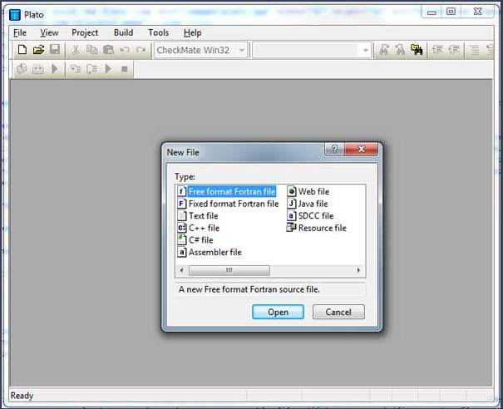
Plato is a "programming environment". Within Plato, you can create and edit programs and get them to run. Plato's editor is special – it understands the syntax of various programming languages. We tell Plato which language we are using when we create our empty file and save it with a .f95 (FORTRAN 95) extension. Provided you have given your file the appropriate extension, Plato's editor will be able to check the syntax of the program, highlighting the various keywords that it knows about using a colour code to distinguish between the various elements of the language. Always ensure that your program files have a .f95 extension
RUNNING YOUR FIRST FORTRAN 95 PROGRAM
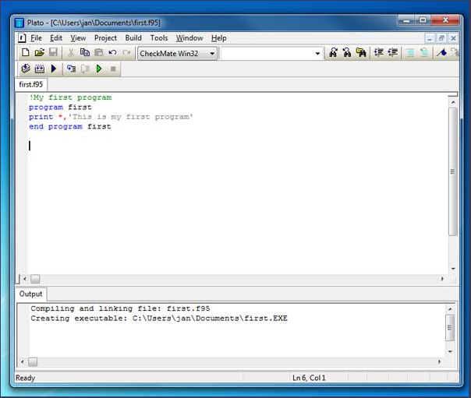

Exercise 1.1
- Type in the following exactly as shown:
!My first program
program first
print *, 'This is my first program'
end program first
FORTRAN ─ BASIC SYNTAX
A FORTRAN program is made of a collection of program units like a main program, modules, and external subprograms or procedures. Each program contains one main program and may or may not contain other program units. The syntax of the main program is as follows:
program program_name
implicit none
! type declaration statements
! executable statements
end program program_name

A SIMPLE PROGRAM IN FORTRAN
Let’s write a program that adds two numbers and prints the result:
program addNumbers
! This simple program adds two numbers
implicit none
! Type declarations
real :: a, b, result
! Executable statements
a = 12.0
b = 15.0
result = a + b
print *, 'The total is ', result
end program addNumbers
When you compile and execute the above program, it produces the following result:
The total is 27.0000000
Please note that:
- All FORTRAN programs start with the keyword program and end with the keyword end program, followed by the name of the program.
- The implicit none statement allows the compiler to check that all your variable types are declared properly. You must always use implicit none at the start of every program.
- Comments in FORTRAN are started with the exclamation mark (!), as all characters after this (except in a character string) are ignored by the compiler.
- The print * command displays data on the screen.
- Indentation of code lines is a good practice for keeping a program readable.
- FORTRAN allows both uppercase and lowercase letters. FORTRAN is case-insensitive, except for string literals.

Basics
The basic character set of FORTRAN contains:
- the letters A ... Z and a ... z
- the digits 0 ... 9
- the underscore (_) character
- the special characters = : + blank - * / ( ) [ ] , . $ ' ! " % & ; < > ?
Tokens are made of characters in the basic character set. A token could be a keyword, an identifier, a constant, a string literal, or a symbol.
Program statements are made of tokens.
Identifier
An identifier is a name used to identify a variable, procedure, or any other user-defined item. A name in FORTRAN must follow the following rules:
- It cannot be longer than 31 characters.
- It must be composed of alphanumeric characters (all the letters of the alphabet, and the digits 0 to 9) and underscores (_).
- First character of a name must be a letter.
- Names are case-insensitive-
Keywords
Keywords are special words, reserved for the language. These reserved words cannot be used as identifiers or names.
The following table, lists the FORTRAN keywords:
Non-I/O keywords
allocatable | allocate | assign | assignment | block data
call | case | character | common | complex
contains | continue | cycle | data | deallocate
default | do | double precision | else | else if
elsewhere | end block data | end do | end function | end if
end interface | end module | end program | end select | end subroutine
end type | end where | entry | equivalence | exit
external | function | go to | if | implicit
in | inout | integer | intent | interface
intrinsic | kind | len | logical | module
namelist | nullify | only | operator | optional
out | parameter | pause | pointer | private
program | public | real | recursive | result
return | save | select case | stop | subroutine
target | then | type | type() | use
Where | While

I/O related keywords
backspace | close | endfile | format | inquire
pen | print | read | rewind | Write

FORTRAN ─ DATA TYPES
FORTRAN provides five intrinsic data types, however, you can derive your own data types as well. The five intrinsic types are:
- Integer type
- Real type
- Complex type
- Logical type
- Character type
Integer Type
The integer types can hold only integer values. The following example extracts the
largest value that can be held in a usual four-byte integer:

program testingInt
implicit none
integer :: largeval
print *, huge(largeval)
end program testingInt

When you compile and execute the above program it produces the following result:
2147483647

Note that the huge() function gives the largest number that can be held by the specific integer data type. You can also specify the number of bytes using the kind specifier. The following example demonstrates this:
program testingInt
implicit none
!two byte integer
integer(kind=2) :: shortval
!four byte integer
integer(kind=4) :: longval
!eight byte integer
integer(kind=8) :: verylongval
!sixteen byte integer
integer(kind=16) :: veryverylongval
!default integer
integer :: defval
print *, huge(shortval)
print *, huge(longval)
print *, huge(verylongval)
print *, huge(veryverylongval)
print *, huge(defval)
end program testingInt

When you compile and execute the above program, it produces the following result:
32767
2147483647
9223372036854775807
170141183460469231731687303715884105727
2147483647

Real Type
It stores the floating point numbers, such as 2.0, 3.1415, -100.876, etc.
The following example shows the use of real data type:
program division
implicit none
! Define real variables
real :: p, q, realRes
! Define integer variables
integer :: i, j, intRes
! Assigning values
p = 2.0
q = 3.0
i = 2
j = 3
! floating point division
realRes = p/q
intRes = i/j
print *, realRes
print *, intRes
end program division

When you compile and execute the above program it produces the following result:
0.666666687
Complex Type
This is used for storing complex numbers. A complex number has two parts, the real part and the imaginary part. Two consecutive numeric storage units store these two parts.
For example, the complex number (3.0, -5.0) is equal to 3.0 – 5.0i
Logical Type
There are only two logical values: .true. and .false.
Character Type
The character type stores characters and strings. The length of the string can be specified by len specifier. If no length is specified, it is 1.
For example,
character (len=40) :: name
name = “Zara Ali”
The expression, name(1:4) would give the substring “Zara”.

Implicit Typing
Older versions of FORTRAN allowed a feature called implicit typing, i.e., you do not have to declare the variables before use. If a variable is not declared, then the first letter of its name will determine its type.
Variable names starting with i, j, k, l, m, or n, are considered to be for integer variable and others are real variables. However, you must declare all the variables as it is good programming practice. For that you start your program with the statement:
implicit none
This statement turns off implicit typing.

FORTRAN ─ VARIABLES
A variable is nothing but a name given to a storage area that our programs can manipulate. Each variable should have a specific type, which determines the size and layout of the variable's memory; the range of values that can be stored within that memory; and the set of operations that can be applied to the variable.
The name of a variable can be composed of letters, digits, and the underscore character.
A name in FORTRAN must follow the following rules:
- It cannot be longer than 31 characters.
- It must be composed of alphanumeric characters (all the letters of the alphabet, and the digits 0 to 9) and underscores (_).
- First character of a name must be a letter.
- Names are case-insensitive.

Variable Declaration
Variables are declared at the beginning of a program (or subprogram) in a type declaration statement.
Syntax for variable declaration is as follows:
type-specifier :: variable_name

The following example demonstrates variable declaration, assignment and display on screen:
program variableTesting
implicit none
! declaring variables
integer :: total
real :: average
complex :: cx
logical :: done
character(len=80) :: message ! a string of 80 characters
!assigning values
total = 20000
average = 1666.67
done = .true.
message = "A big Hello from Tutorials Point"
cx = (3.0, 5.0) ! cx = 3.0 + 5.0i
Print *, total
Print *, average
Print *, cx
Print *, done
Print *, message
end program variableTesting

When the above code is compiled and executed, it produces the following result:
20000
1666.67004
(3.00000000, 5.00000000 )
T
A big Hello from Tutorials Point

FORTRAN ─ CONSTANTS
The constants refer to the fixed values that the program cannot alter during its execution. These fixed values are also called literals.
Constants can be of any of the basic data types like an integer constant, a floating constant, a character constant, a complex constant, or a string literal. There are only two logical constants : .true. and .false.
The constants are treated just like regular variables, except that their values cannot be modified after their definition.
There are two types of constants:
- Literal constants
- Named constants
A literal constant have a value, but no name.
A named constant has a value as well as a name.
Named constants should be declared at the beginning of a program or procedure, just like a variable type declaration, indicating its name and type. Named constants are declared with the parameter attribute. For example,
real, parameter :: pi = 3.1415927
Example
The following program calculates the displacement due to vertical motion under gravity.
program gravitationalDisp
! this program calculates vertical motion under gravity
implicit none
! gravitational acceleration
real, parameter :: g = 9.81
! variable declaration
real :: s ! displacement
real :: t ! time
real :: u ! initial speed
! assigning values
t = 5.0
u = 50
! displacement
s = u * t - g * (t**2) / 2
! output
print *, "Time = ", t
print *, 'Displacement = ',s
end program gravitationalDisp

When the above code is compiled and executed, it produces the following result:
Time = 5.00000000
Displacement = 127.374992

FORTRAN ─ OPERATORS
An operator is a symbol that tells the compiler to perform specific mathematical or logical manipulations. FORTRAN provides the following types of operators:
- Arithmetic Operators
- Relational Operators
- Logical Operators
Let us look at all these types of operators one by one.
Arithmetic Operators
Following table shows all the arithmetic operators supported by FORTRAN. Assume variable A holds 5 and variable B holds 3 then:

Operator | Description | Example
+ | Addition Operator, adds two operands. | A + B will give 8
- | Subtraction Operator, subtracts second operand  from the first. | A - B will give 2
* | Multiplication Operator, multiplies both operands. | A * B will give 15
/ | Division Operator, divides numerator by de  numerator. | A / B will give 1
** | Exponentiation Operator, raises one operand to the  power of the other. | A ** B will give 125
Example
Try the following example to understand all the arithmetic operators available in Fortran:
program arithmeticOp
! this program performs arithmetic calculation
implicit none
! variable declaration
integer :: a, b, c
! assigning values
a = 5
b = 3
! Exponentiation
c = a ** b
! output
print *, "c = ", c
! Multiplication
c = a * b
! output
print *, "c = ", c
! Division
c = a / b
! output
print *, "c = ", c
! Addition
c = a + b
! output
print *, "c = ", c
! Subtraction
c = a - b
! output
print *, "c = ", c
end program arithmeticOp

When you compile and execute the above program, it produces the following result:
c = 125
c = 15
c = 1
c = 8
c = 2

Relational Operators
Following table shows all the relational operators supported by FORTRAN. Assume variable A holds 10 and variable B holds 20, then:
Operator | Equivalent | Description | Example
== | .eq. | Checks if the values of two operands are  equal or not, if yes then condition becomes  true. | (A == B) is  not true.
/= | .ne. | Checks if the values of two operands are  equal or not, if values are not equal then  condition becomes true. | (A != B) is  true.
> | .gt. | Checks if the value of left operand is greater  than the value of right operand, if yes then  condition becomes true. | (A > B) is  not true.
< | .lt. | Checks if the value of left operand is less  than the value of right operand, if yes then  condition becomes true. | (A < B) is  true.
>= | .ge. | Checks if the value of left operand is greater  than or equal to the value of right operand, if  yes then condition becomes true. | (A >= B) is  not true.
<= | .le. | Checks if the value of left operand is less  than or equal to the value of right operand, if  yes then condition becomes true. | (A <= B) is  true.

Example
Try the following example to understand all the logical operators available in Fortran:
program logicalOp
! this program checks logical operators
implicit none
! variable declaration
logical :: a, b
! assigning values
a = .true.
b = .false.
if (a .and. b) then
print *, "Line 1 - Condition is true"
else
print *, "Line 1 - Condition is false"
end if
if (a .or. b) then
print *, "Line 2 - Condition is true"
else
print *, "Line 2 - Condition is false"
end if
! changing values
a = .false.
b = .true.
if (.not.(a .and. b)) then
print *, "Line 3 - Condition is true"
else
print *, "Line 3 - Condition is false"
end if
if (b .neqv. a) then
print *, "Line 4 - Condition is true"
else
print *, "Line 4 - Condition is false"
end if
if (b .eqv. a) then
print *, "Line 5 - Condition is true"
else
print *, "Line 5 - Condition is false"
end if
end program logicalOp
When you compile and execute the above program it produces the following result:
Line 1 - Condition is false
Line 2 - Condition is true
Line 3 - Condition is true
Line 4 - Condition is true
Line 5 - Condition is false

Logical Operators
Logical operators in FORTRAN work only on logical values .true. and .false.
The following table shows all the logical operators supported by FORTRAN. Assume variable A holds .true. and variable B holds .false. , then:
Operator | Description | Example
.and. | Called Logical AND operator. If both the  operands are non-zero, then condition becomes  true. | (A .and. B) is false.
.or. | Called Logical OR Operator. If any of the two  operands is non-zero, then condition becomes  true. | (A .or. B) is true.
.not. | Called Logical NOT Operator. Use to reverses the  logical state of its operand. If a condition is true  then Logical NOT operator will make false. | !(A .and. B) is true.
.eqv. | Called Logical EQUIVALENT Operator. Used to  check equivalence of two logical values. | (A .eqv. B) is false.
.neqv. | Called Logical NON-EQUIVALENT Operator. Used  to check non-equivalence of two logical values. | (A .neqv. B) is true.

Example
Try the following example to understand all the logical operators available in Fortran:
program logicalOp
! this program checks logical operators
implicit none
! variable declaration
logical :: a, b
! assigning values
a = .true.
b = .false.
if (a .and. b) then
print *, "Line 1 - Condition is true"
else
print *, "Line 1 - Condition is false"
end if
if (a .or. b) then
print *, "Line 2 - Condition is true"
else
print *, "Line 2 - Condition is false"
end if
! changing values
a = .false.
b = .true.
if (.not.(a .and. b)) then
print *, "Line 3 - Condition is true"
else
print *, "Line 3 - Condition is false"
end if
if (b .neqv. a) then
print *, "Line 4 - Condition is true"
else
print *, "Line 4 - Condition is false"
end if
if (b .eqv. a) then
print *, "Line 5 - Condition is true"
else
print *, "Line 5 - Condition is false"
end if
end program logicalOp

When you compile and execute the above program it produces the following result:
Line 1 - Condition is false
Line 2 - Condition is true
Line 3 - Condition is true
Line 4 - Condition is true
Line 5 - Condition is false

Operators Precedence in FORTRAN
Operator precedence determines the grouping of terms in an expression. This affects how an expression is evaluated. Certain operators have higher precedence than others; for example, the multiplication operator has higher precedence than the addition operator.
For example, x = 7 + 3 * 2; here, x is assigned 13, not 20 because operator * has higher precedence than +, so it first gets multiplied with 3*2 and then adds into 7.
Category | Operator
Logical NOT and negative sign | .not. (-)
Exponentiation | **
Multiplicative | * /
Additive | + -
Relational | < <= > >=
Equality | == !=
Logical AND | .and.
Logical OR | .or.
Assignment | =

FORTRAN ─ CONTROL STRUCTURE
Control structures are used to direct the flow of program execution. It require that the programmer specify one or more conditions to be evaluated or tested by the program, along with a statement or statements to be executed, if the condition is determined to be true, and optionally, other statements to be executed if the condition is determined to be false.
Fortran provides the following types of control constructs.
FORTRAN SELECTION STATEMENTS
If…then Construct
An if… then statement consists of a logical expression followed by one or more statements and terminated by an end if statement. It is used for single selection.
Syntax
The basic syntax of an if… then statement is:
if (logical expression) then
statement
end if

If the logical expression evaluates to true, then the block of code inside the if…then statement will be executed. If logical expression evaluates to false, then the first set of code after the end if statement will be executed.
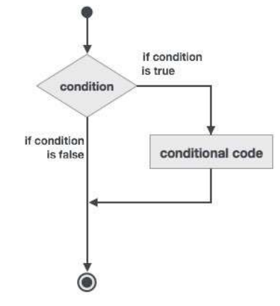
Example 1
program ifProg
implicit none
! local variable declaration
integer :: a = 10
! check the logical condition using if statement
if (a < 20 ) then

! if condition is true then print the following
print*, "a is less than 20"
end if

print*, "value of a is ", a
end program ifProg

If… then… else Construct
An if… then statement can be followed by an optional else statement, which executes when the logical expression is false.
Syntax
The basic syntax of an if… then… else statement is:
if (logical expression) then
statement(s)
else
other_statement(s)
end if

Flow Diagram
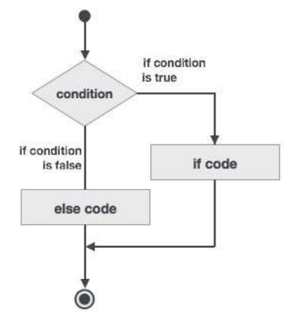

Example 2
program ifElseProg
implicit none
! local variable declaration
integer :: a = 100
! check the logical condition using if statement
if (a < 20 ) then

! if condition is true then print the following
print*, "a is less than 20"
else
print*, "a is not less than 20"
end if
print*, "value of a is ", a
end program ifElseProg
if...else if...else Statement
An if statement construct can have one or more optional else-if constructs. When the ifcondition fails, the immediately followed else-if is executed. When the else-if also fails, its successor else-if statement (if any) is executed, and so on.
The optional else is placed at the end and it is executed when none of the above conditions hold true.
- All else statements (else-if and else) are optional.
- else-if can be used one or more times
- else must always be placed at the end of construct and should appear only once.
Syntax
The syntax of an if...else if...else statement is:
[name:]
if (logical expression 1) then
! block 1
else if (logical expression 2) then
! block 2
else if (logical expression 3) then
! block 3
else
! block 4
end if [name]
Example
program ifElseIfElseProg
implicit none
! local variable declaration
integer :: a = 100
! check the logical condition using if statement
if( a == 10 ) then

! if condition is true then print the following
print*, "Value of a is 10"

else if( a == 20 ) then

! if else if condition is true
print*, "Value of a is 20"

else if( a == 30 ) then

! if else if condition is true
print*, "Value of a is 30"
else
! if none of the conditions is true
print*, "None of the values is matching"
end if
print*, "exact value of a is ", a
end program ifElseIfElseProg

Select Case Construct
A select case statement allows a variable to be tested for equality against a list of values. Each value is called a case, and the variable being selected on is checked for each select case.

Syntax
The syntax for the select case construct is as follows:
[name:] select case (expression)
case (selector1)
! some statements
... case (selector2)
! other statements
...
case default
! more statements
...
end select [name]
Example
program selectCaseProg
implicit none
! local variable declaration
character :: grade = 'B'
select case (grade)

case ('A')
print*, "Excellent!"

case ('B')
case ('C')
print*, "Well done"

case ('D')
print*, "You passed"
case ('F')
print*, "Better try again"

case default
print*, "Invalid grade"
end select
print*, "Your grade is ", grade
end program selectCaseProg
FORTRAN REPETITION STATEMENTS
A loop statement allows us to execute a statement or group of statements multiple times.
- do loop: This construct enables a statement, or a series of statements, to be carried out iteratively, while a given condition is true.
- do while loop: Repeats a statement or group of statements while a given condition is true. It tests the condition before executing the loop body.
- nested loops: You can use one or more loop construct inside any other loop construct.

do loop:
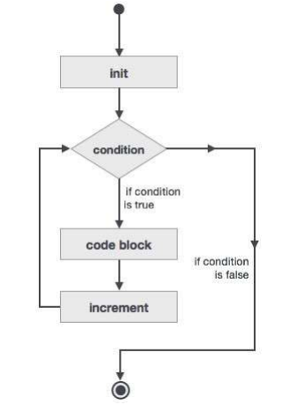

Example
This program calculates the factorials of numbers 1 to 10:
program factorial
implicit none
! define variables
integer :: nfact = 1
integer :: n

! compute factorials
do n = 1, 10
nfact = nfact * n
! print values
print*, n, " ", nfact
end do
end program factorial

do while loop:
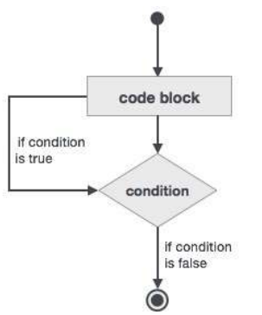

Example
program factorial
implicit none
! define variables
integer :: nfact = 1
integer :: n = 1

! compute factorials
do while (n <= 10)
nfact = nfact * n
n = n + 1
print*, n, " ", nfact
end do
end program factorial

